Kumami World — Full Product Specification
Every product, on every tier, the exact data source & API used, and how each result is calculated. INTERNAL reference (names the data provider) — the customer-facing product never surfaces the provider name.

Contents
Right-click and choose 'Update Field' to build the table of contents.

Kumami Basic
Kumami Basic is the free, always-on tier — the entire onboarding, learning, news, and community surface of the platform. There is no logged-out preview: the whole shell sits behind a Firebase auth gate (WorldProtected), and once inside, every Basic feature is fully open to any authenticated user regardless of premium status. The one exception is News, where individual PRO-flagged articles are visually gated as an upsell into Pro — that is an upsell mechanic layered onto Basic, not a restriction of Basic content itself.

1. Home
The brand story page — not a personalized dashboard.

What it is
The original Kumami marketing/landing page (“About Kumami”), reused verbatim inside the World shell. It is a static composition, not a per-user dashboard: Hero → Ecosystem anchor → Moving tagline → Trending News / Numbers / Blog Updates / FAQ (over a background image) → Partners → Contact → Footer.

Where it is
Tier: visible in all three workspace modes (Basic/Plus/Pro) — not gated to Basic only.
Nav path: Sidebar → Home. It is the only item that sits outside every collapsible group, directly under the brand logo/workspace switcher — always the first thing in the sidebar regardless of mode.
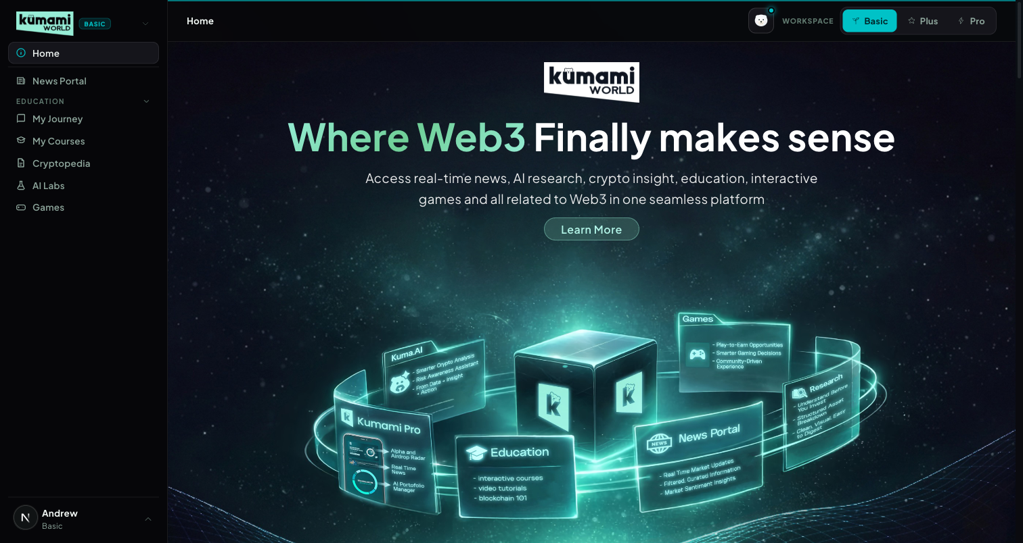
Figure: Home in Basic mode — sidebar shows Home as a standalone top item; page shows Hero → Ecosystem → Trending News → Numbers → Our Journey → FAQ → Partners → Contact → Footer.

How the user uses it
Land here after logging in, or click “Home” anytime to return. It's a scroll-and-read page: click “Learn More” in the hero to jump to the Ecosystem anchor; use the Trending News carousel's ‹ › arrows to browse recent headlines and click “Read More” to open the full article; click any Partner logo to open that partner's external site in a new tab; click “See more” under Our Journey to open the full Blogs grid; click a FAQ question to expand its answer; click “Join Our Community” to open the community CTA.

How we build it

Via API
None for the page shell itself — it's a stack of legacy marketing components with no page-level fetch.

Via Admin Dashboard (manual)
Its live sub-sections are each authored separately:
- Trending News strip — reads Firestore news (same collection/admin flow as News Portal, below).
- Our Journey blog highlight — reads Firestore blogs, authored at Content → Blog → Publish Blog (/admin/blog): Title, Read Time, Thumbnail/Detail images, Summary, Content Section 1/2 → Publish Blog or Save as Draft. Edit via Content → Blog → Edit Blog; drafts at Content → Blog → Blog Drafts.
- Partners strip — reads Firestore homepage_partners, authored at Management → Partners → Homepage Partners (/admin/homepage-partners) — a curated subset of the full directory (Management → Partners → All Partners).
Computed, not manually entered: the Total Users / Partners counters run a live Firestore .count() aggregation over the users and all_partners collections at request time — always the real current count, never hand-typed.
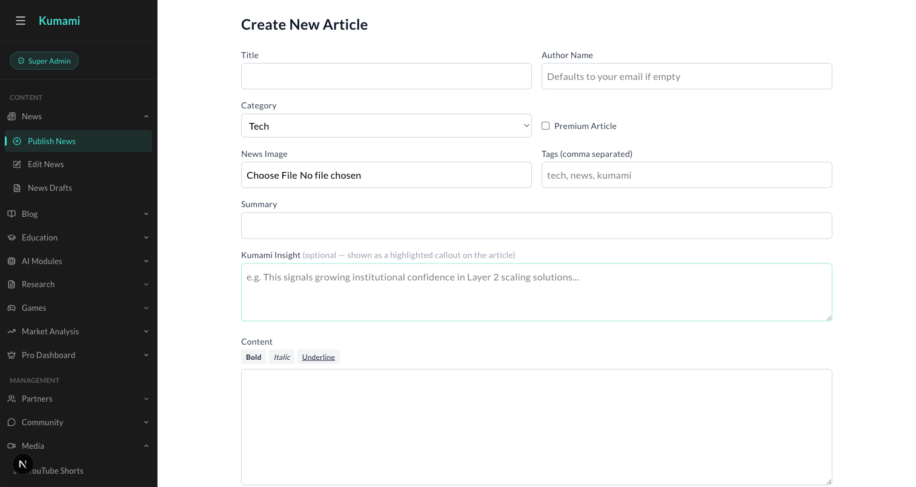
Figure: Content → News → Publish News — the admin form behind the Trending News strip and the News Portal below.
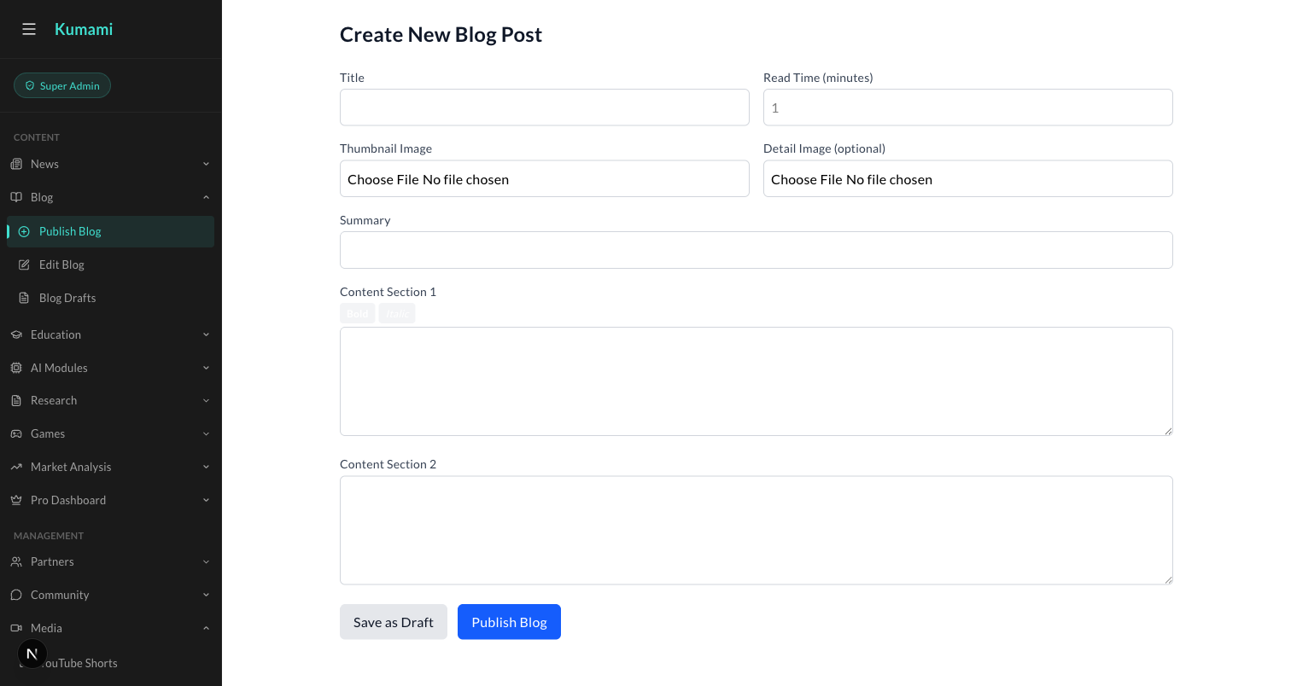
Figure: Content → Blog → Publish Blog — the admin form behind Home's Our Journey highlight.

2. News Portal
The daily crypto/Web3 news feed — hero, latest, and a river of stories.

What it is
The main news feed: a live ticker, a hero story, a ‘Latest’ aside, an upsell banner into Plus/Pro, and a river of further articles.

Where it is
Tier: Basic.
Nav path: Sidebar → News Portal (standalone item, directly below Home — not inside a group).
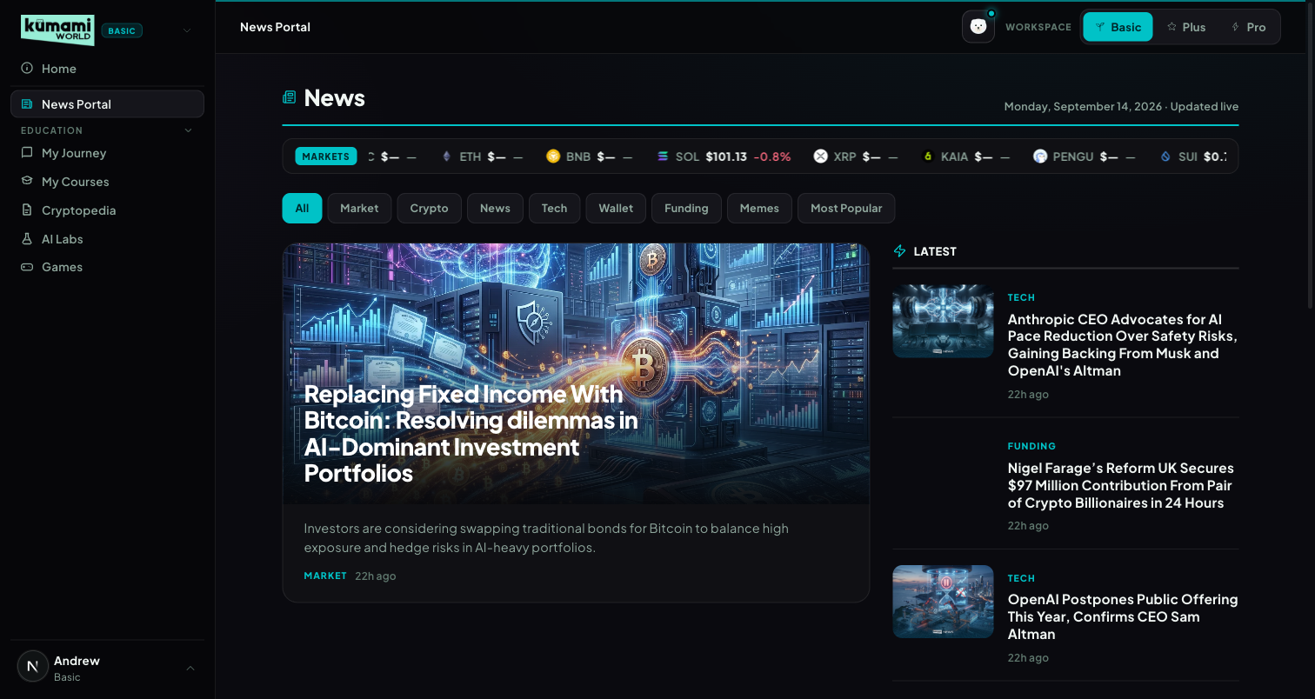
Figure: News Portal in Basic mode — live ticker, category pills, hero story, Latest aside.

How the user uses it
Read the live price ticker at the top; click a category pill (All / Market / Crypto / News / Tech / Wallet / Funding / Memes / Most Popular — pills are generated from whatever categories actually exist in Firestore, not hardcoded) to filter the river; click the hero image or headline, or any Latest/river card, to open the full article at /world/news/[id]; scroll past the “MORE NEWS” river grid and click “View all news” for the full paginated list. Articles flagged Pro in Firestore show a dimmed lock veil — clicking it routes to /world/pro instead of opening the article.

How we build it

Via Admin Dashboard (manual)
Firestore news, authored at Content → News → Publish News (/admin/news): Title, Author Name (defaults to your email if left empty), Category (dropdown), tick “Premium Article” to Pro-gate it, upload a News Image, comma-separated Tags, Summary, optional “Kumami Insight” callout box, then the main Content body → Publish. Edit existing articles via Content → News → Edit News (/admin/edit-news); unpublished work sits in Content → News → News Drafts (/admin/news-drafts).

Via API
Only the live ticker — 10 coins (BTC, ETH, BNB, SOL, XRP, KAIA, PENGU, SUI, DOGE, POL) pushed over a WebSocket (wss://tickerworker.kumamiworldapp.workers.dev/), a Cloudflare Worker proxying Binance's real-time @ticker stream — push-based, not a polling REST call, auto-reconnects 1s after any drop.
Figure: Content → News → Publish News — the exact form used to author every News Portal article.

3. Education — My Journey & My Courses
Two tabs, one underlying engine: a first-timer intro that becomes a personal dashboard once you start.

What it is
Basic's learning system: 5 fixed levels totaling 65 lessons (~19 hours), each tracked per-user at chapter and section granularity. ‘My Journey’ is a smart tab — first-time visitors see an intro/level-picker; anyone with any progress sees the Dashboard experience instead, automatically, with no separate setting to toggle.
# | Tag | Title | Badge | Duration | Chapters
1 | Beginner | Start Here | First Steps | 2h 10m | 7
2 | Elementary | Understand What You Just Bought | Under the Hood | 3h 40m | 12
3 | Intermediate | Learn to Trade | Sharp Eye | 5h 05m | 17
4 | Advanced | Think Like an Investor | Market Mind | 3h 55m | 12
5 | Expert | Go Deeper | Web3 Native | 4h 20m | 12

Where it is
Tier: Basic.
Nav path: Sidebar → Education (collapsible group) → My Journey, or Sidebar → Education → My Courses.
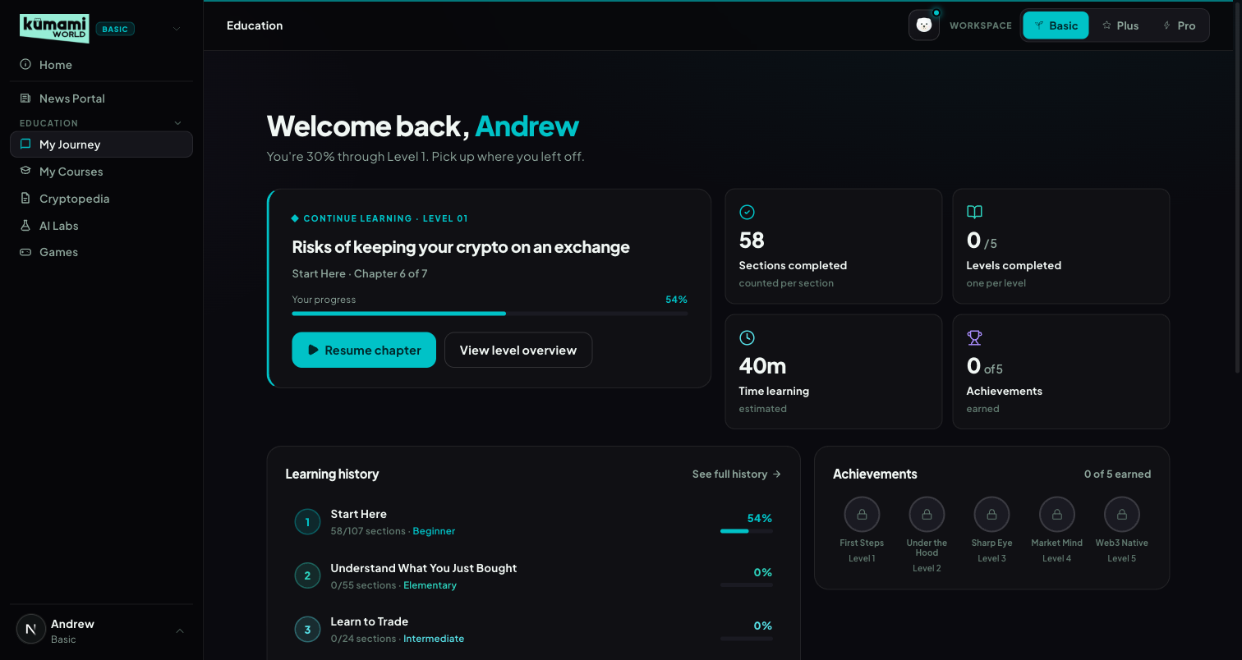
Figure: My Journey, returning-user Dashboard state — welcome banner, Continue Learning card, stats, learning history, achievements.
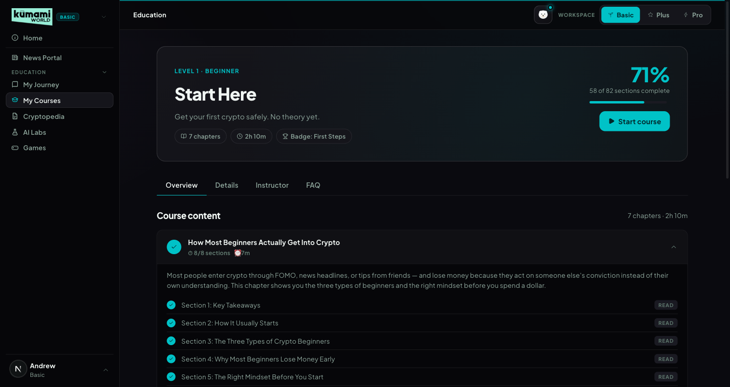
Figure: My Courses, Level 1 detail — progress bar, Overview/Details/Instructor/FAQ tabs, chapter accordion with per-section Read checklist.

How the user uses it
First-time state (My Journey): click a level card, or the “Start Level 1” CTA, to begin. Returning state (My Journey): the same tab now shows a Dashboard — click “Resume chapter” on the Continue Learning card to jump straight back into the exact chapter/section left off, or “View level overview” to see the full level. My Courses: pick a level (via the level cards or the ?level=1-5 URL), work through the Overview tab's chapter accordion, click “Read” on each section to mark it complete, and switch to Details / Instructor / FAQ for the level blurb, instructor bio, and the FAQ (which states plainly that all 5 levels are completely free).

How we build it

Via Admin Dashboard (manual)
Chapter content lives in Firestore education_articles, authored at Content → Education → Publish Education (/admin/education): choose Level (dropdown, Level 1-5) and Chapter position (0-based index — sets ordering within that level; the article title becomes the chapter name), Author, Read time, tick “Featured lesson” or “Coming soon” (placeholder, no content yet) as needed, Blurb (1-2 sentence card summary), Description (SEO meta), Thumbnail, then build the body in Content Sections using either the Classic or TipTap editor — a Live Preview panel mirrors the breadcrumb and content live as you type. Edit via Content → Education → Edit Education; drafts sit at Content → Education → Education Drafts.

Via API
None — progress is per-user Firestore state, not an external fetch. Stored at users/{uid}/education_progress/{levelNum} (falls back to localStorage when logged out). Progress % is section-based, not chapter-based: pct = round(completedSections / totalSections × 100), summed per level and overall on the Dashboard.
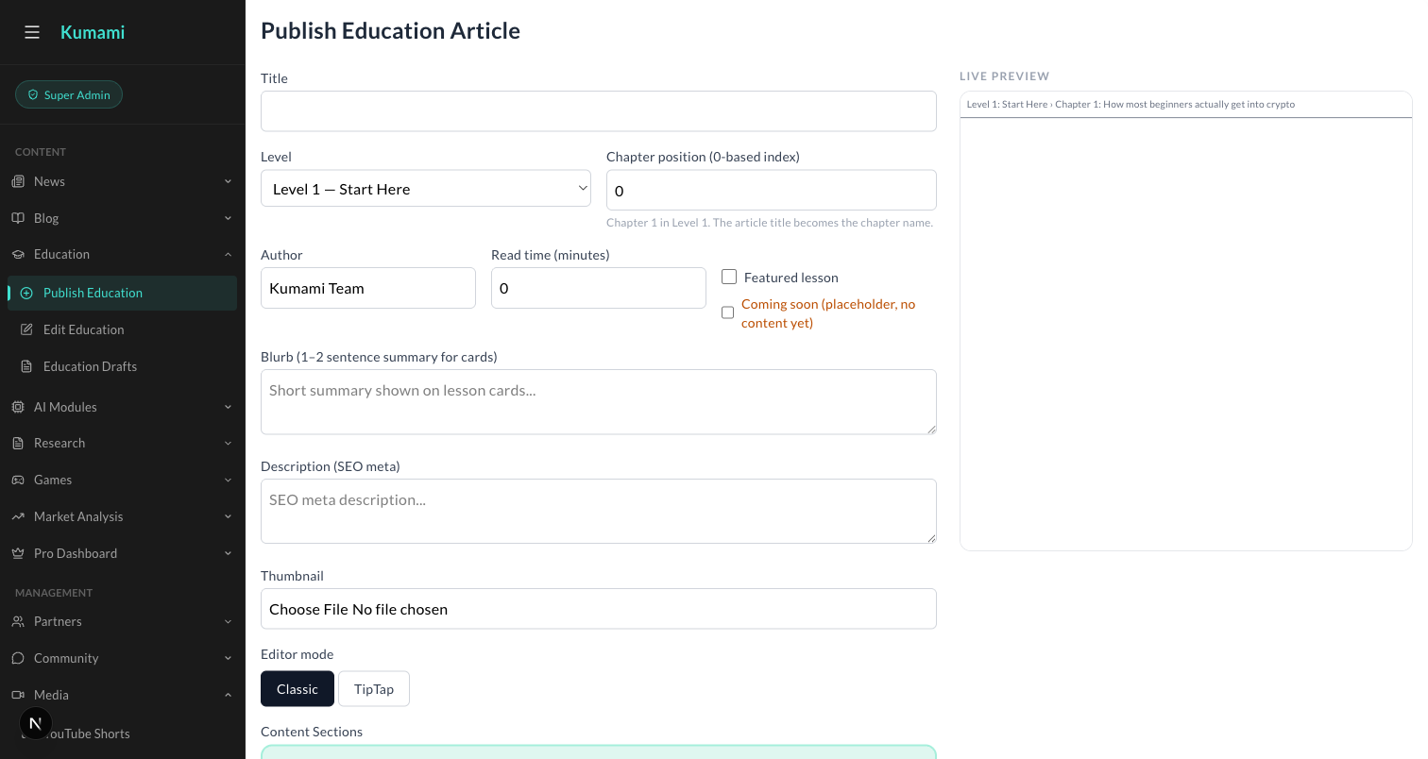
Figure: Content → Education → Publish Education — Level dropdown, Chapter position, Content Sections editor with Live Preview.

4. Cryptopedia — Tokenpedia & Glossary
An onchain asset directory and a plain-language glossary, unified under one capsule selector.

What it is
A reference-desk tab with an underline-style capsule toggle between two views: Tokenpedia (?view=tokenpedia, default) and Glossary (?view=glossary).

Where it is
Tier: Basic.
Nav path: Sidebar → Education (group) → Cryptopedia — its own item alongside My Journey/My Courses inside the same group.
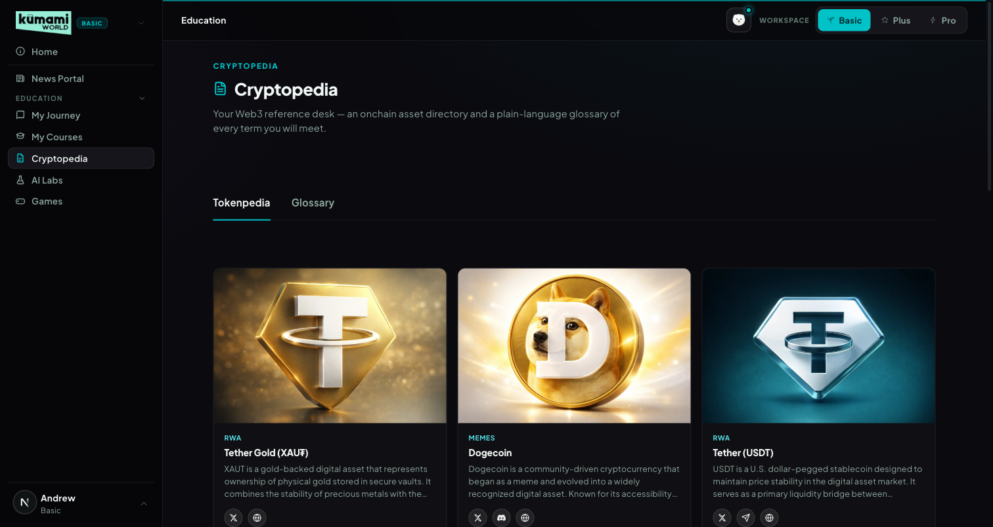
Figure: Cryptopedia → Tokenpedia view — card grid of on-chain assets/projects with social links.
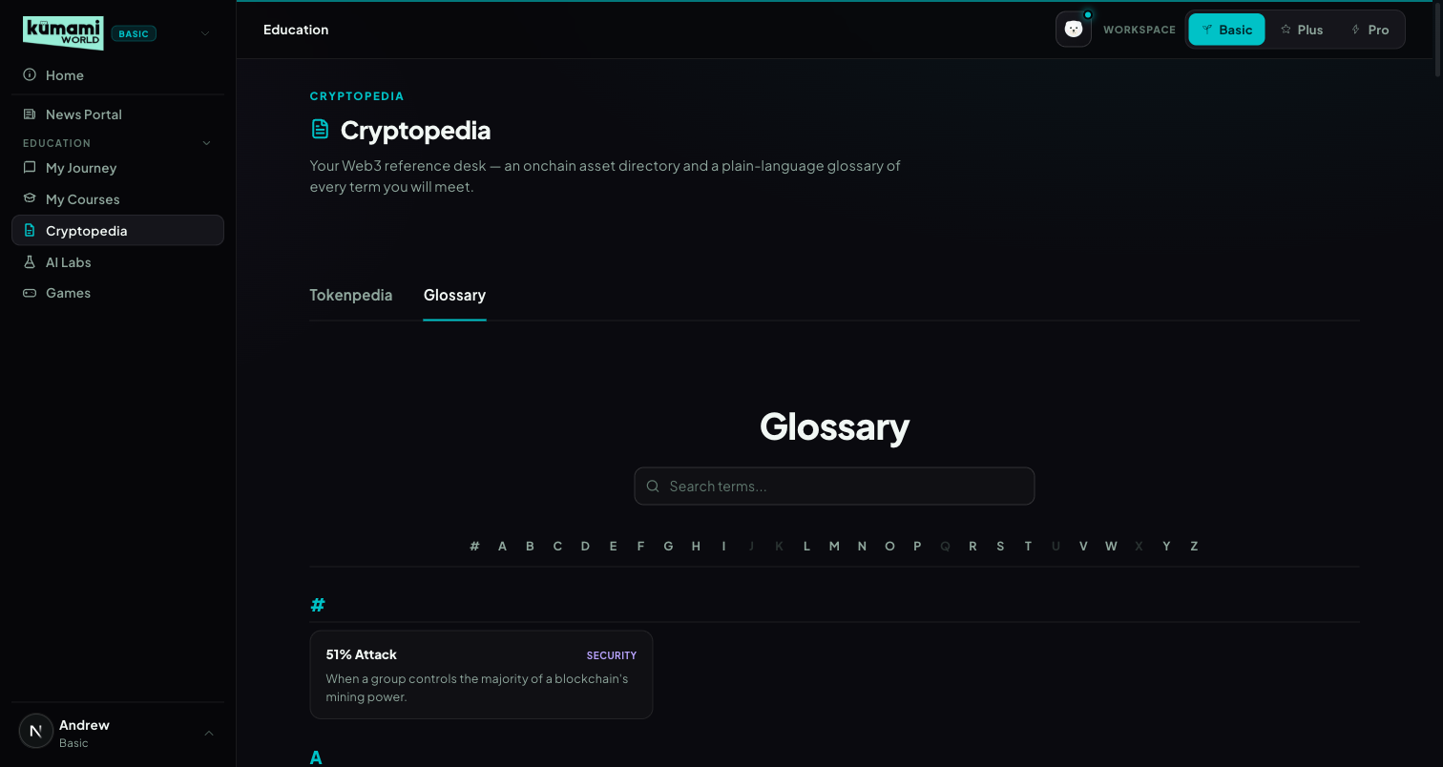
Figure: Cryptopedia → Glossary view — searchable, A–Z indexed term list.

How the user uses it
Land on Tokenpedia by default — click any project card to open its detail page (/world/research/[id]) with its description and X/Discord/Telegram/Website links. Click the “Glossary” capsule to switch views; type in the search box (matches term/definition/category) or click a letter in the A–Z index to jump; click any term to open its detail page (/world/glossary/[id]).

How we build it

Tokenpedia — Via Admin Dashboard (manual)
Firestore research_articles, authored at Content → Research → Publish Research (/admin/research): Title, Author, Category (dropdown, e.g. “Web 3 Platform”), Research Image (Main), Short Description, one or more Content Sections, optional Detail Image 2 → Publish. Edit via Content → Research → Edit Research; drafts at Content → Research → Research Drafts.

Glossary — Via Code only
No admin panel today: a fully static file, src/data/glossaryData.ts — 147 hardcoded {id, term, category, definition} entries, no Firestore involved. Adding or editing a term currently requires a developer to change that file and deploy — there is no admin UI for it. Flagged here as a gap if the team wants to manage terms without a developer.
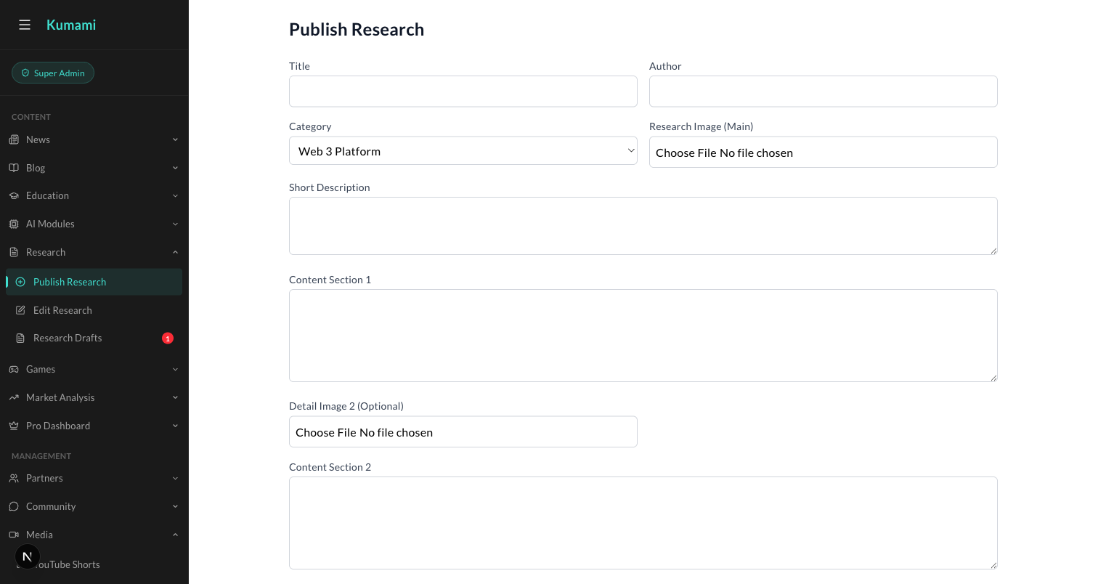
Figure: Content → Research → Publish Research — the admin form behind every Tokenpedia card.

5. AI Labs
A marketing placeholder for an upcoming AI + Web3 hub — no live tools yet.

What it is
An informational page previewing 3 planned features. 100% static — a hardcoded featureCards array, no Firestore, no API.

Where it is
Tier: Basic.
Nav path: Sidebar → AI Labs (standalone item, below the Education group).
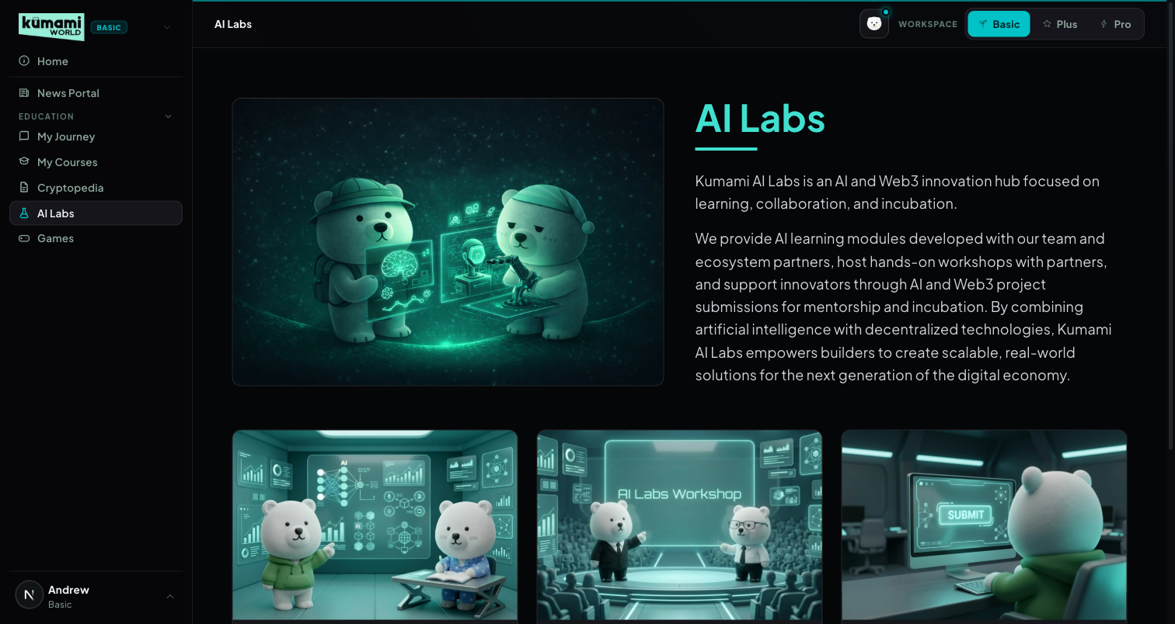
Figure: AI Labs — hero + intro copy, 3 “Coming Soon” feature cards (Module, Workshop, Submission).

How the user uses it
Read-only today — scroll through the hero and the 3 feature cards. Each card's button is disabled and reads “Coming Soon”; there is no interactive action to take yet.

How we build it

Via Code only
A hardcoded featureCards array inside the page component. No Firestore, no API, no admin panel — any copy or card change requires a developer to edit the code and deploy.

6. Games
An interactive-learning games catalog with a featured carousel and category rails.

What it is
A games portal: a featured carousel plus category-filtered rails (Most Popular, Free to Play, Coming Soon).

Where it is
Tier: Basic.
Nav path: Sidebar → Games (standalone item, bottom of the Basic sidebar).
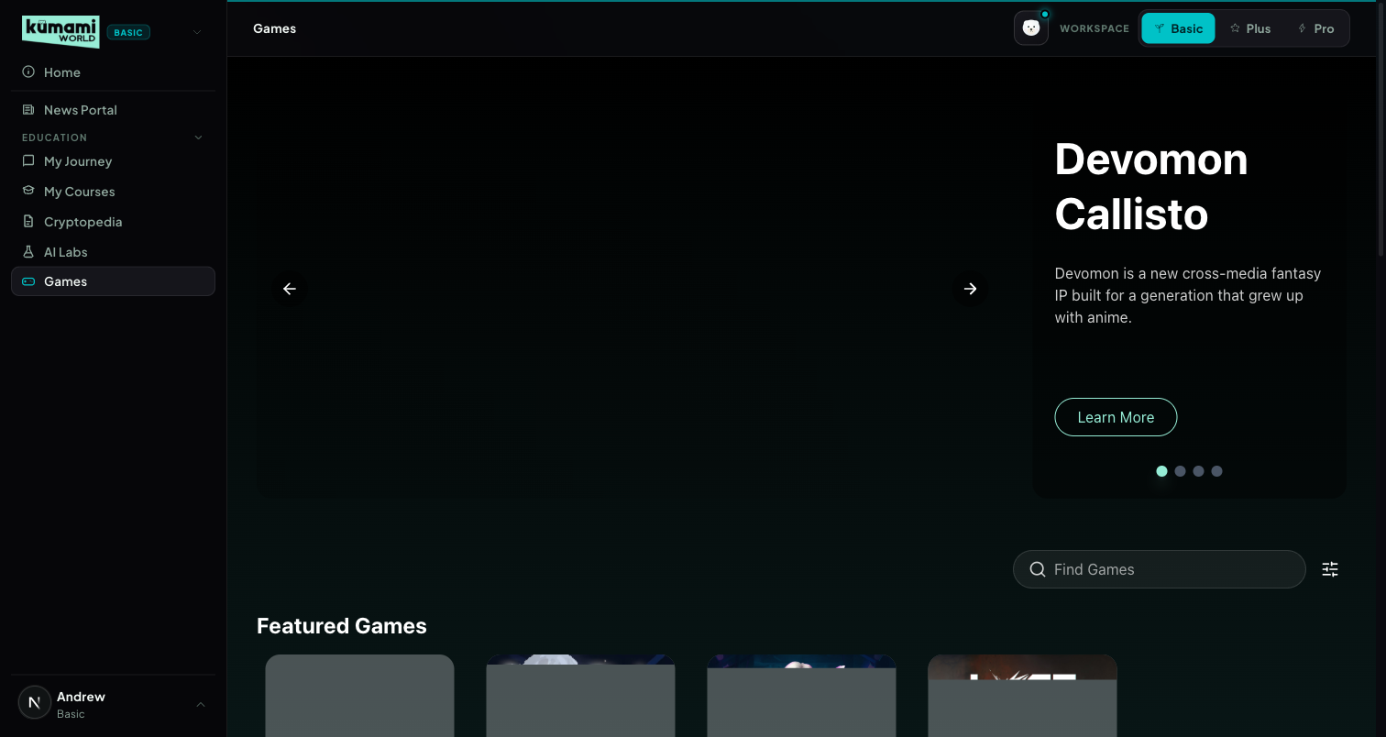
Figure: Games — featured carousel, search + platform filter, category rails below.

How the user uses it
Browse the auto-advancing featured carousel (every 8s) or use the ‹ › arrows / pagination dots to control it manually; type in “Find Games” to search by title/tagline/genre/platform, or open the filter icon to tick a Platform (PC / Website / Mobile App); scroll the All Games, Most Popular, Free to Play, and Coming Soon rails below; click any game card to open its detail page (/world/games/details?name=<title>); click “View More” on the All Games rail to see the full catalog.

How we build it

Via Admin Dashboard (manual)
Firestore games, authored at Content → Games → Publish Games (/admin/games): Game Title, Tagline, Genres (checkboxes), Networks (checkboxes), Platform Types (checkboxes), Categories (Featured / Free to Play / Most Popular / Coming Soon — checkboxes), Released On date, plus multiple image variants (portrait/catalog/landscape/detail/carousel) → Publish. Edit via Content → Games → Edit Games; drafts at Content → Games → Game Drafts.

Via API
None.
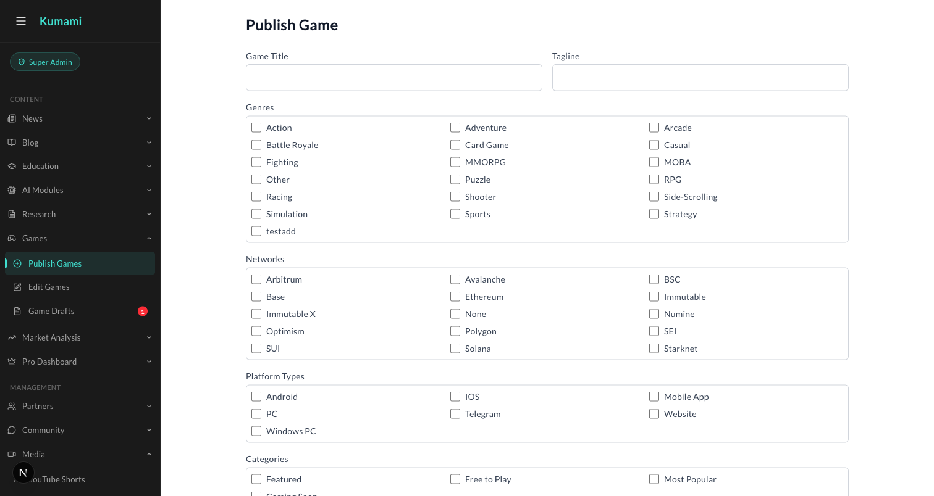
Figure: Content → Games → Publish Games — the admin form behind every Games catalog entry.

Kumami Plus
Kumami Plus is the “Advanced” tier — a fixed 5-asset universe (BTC, ETH, SOL, BNB, HYPE) across 8 tools. Every panel runs through the same 4-stage pipeline: (1) live data fetched from the CoinGlass v4 API, (2) cached briefly and shared across panels, (3) fed into a rule engine that converts raw numbers into a verdict + color using fixed thresholds, and (4) rendered. The interpretation layer — not the data — is the product. Data is delayed ~15 minutes on Plus; Pro removes that delay and widens the asset universe (see the Kumami Pro section).

1. Console
The 10-second daily briefing — aggregates every other Plus tool onto one screen.

What it is
The first screen Plus users land on. Fuses market sentiment, four macro tiles, five per-asset regime chips, and live previews of On-Chain Insights, Flow Radar, Intelligence, and the auto-curated Watchlist — all in one scroll, zero extra clicks.

Where it is
Tier: Plus.
Nav path: Sidebar → Plus (group) → Console. Console is also the landing page you reach first when you switch to the Plus workspace.
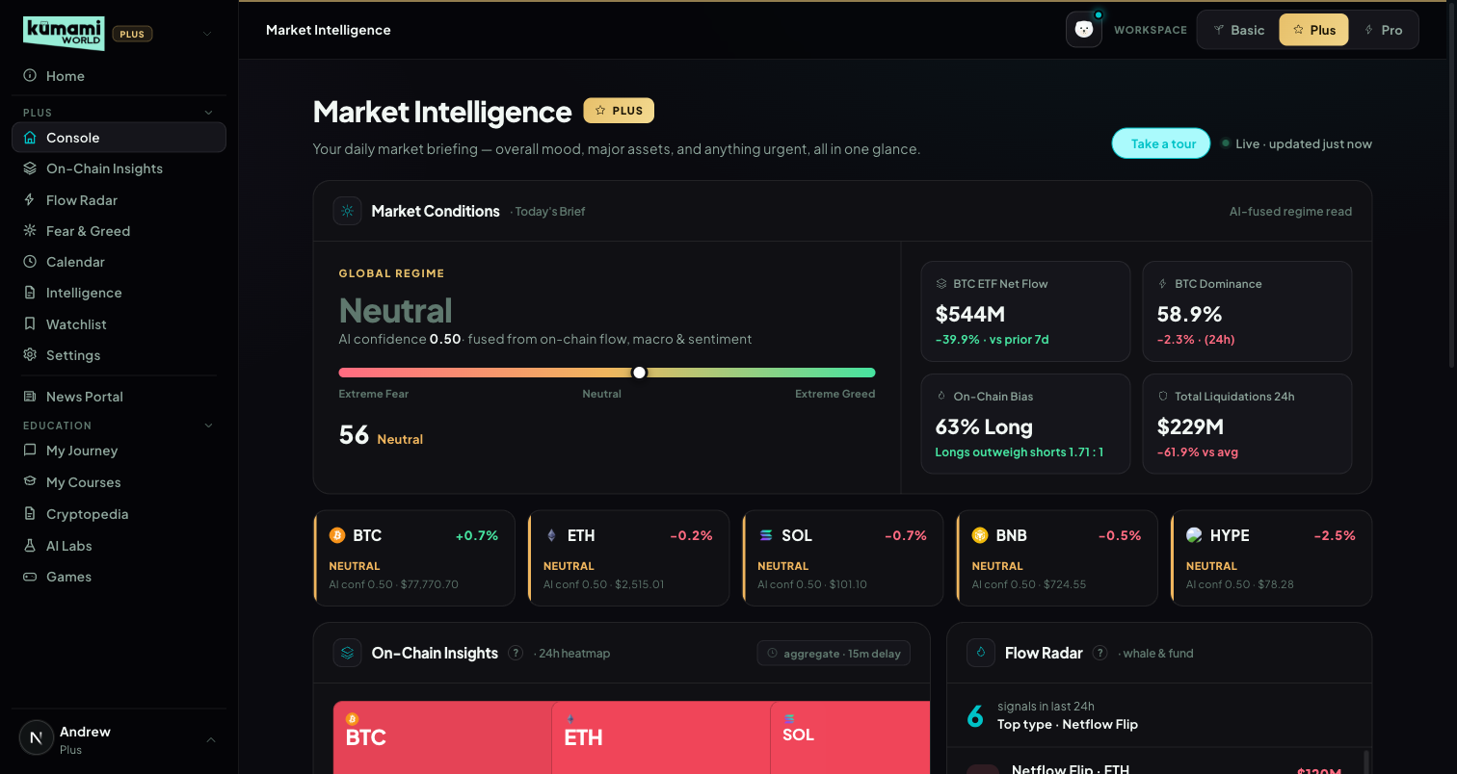
Figure: Console — Market Conditions regime, 4 macro tiles, 5 asset regime chips, and preview panels below.

How the user uses it
Scroll top to bottom for the full briefing: read the Global Regime word and confidence score, glance at the 4 macro tiles (BTC ETF Net Flow, BTC Dominance, On-Chain Bias, Total Liquidations 24H), check each of the 5 asset regime chips (BTC/ETH/SOL/BNB/HYPE), then use the preview panels below (On-Chain heatmap, Flow Radar, Intelligence, Auto-Watchlist) as jump-off points — each has an “Open X →” link into its full tab.

How we build it

Via API

1.1 Market Conditions — Global Regime & Fear/Greed
Data in: Fear & Greed index (0–100), 7-day BTC/ETH ETF flow direction, OI-weighted funding rate, OI-vs-price trend.
API: /api/index/fear-greed-history · /api/etf/bitcoin/flow-history · /api/etf/ethereum/flow-history · /api/futures/funding-rate/oi-weight-history · /api/futures/open-interest/aggregated-history · /api/futures/pairs-markets
How it's calculated: 4 inputs, each scored −1/0/+1, summed, then NORMALIZED by dividing by the count of non-zero (“active”) signals — a deliberate fix over a raw fixed-threshold sum, so the verdict stays meaningful even when some signals return neutral rather than diluting the bands with dead weight. Long/Short bias is intentionally NOT part of this composite — it still drives the standalone On-Chain Bias macro tile below, just not this score.
Signal | Scoring
Fear & Greed | 0–45 → +1 (contrarian) · 46–55 → 0 · 56–100 → −1
ETF Flow (7D) | positive 7D flow → +1 · 0 → 0 · negative → −1 (pre-scored by caller)
Funding Rate | > +0.10% → −1 (overheated long) · 0…+0.10% → 0 · negative → +1 (contrarian bullish)
OI vs Price | both rising → +1 · OI rising + price flat → −1 · everything else → 0
Normalized score = (sum of the 4 scores) / (count of non-zero scores). Verdict bands on the NORMALIZED score:
Normalized score | Verdict | Color
≥ +0.60 | Strongly Bullish | green
+0.25 to +0.60 | Cautiously Bullish | grey-green
−0.25 to +0.25 | Neutral | grey
−0.60 to −0.25 | Cautiously Bearish | grey-red
< −0.60 | Strongly Bearish | red
Confidence floor (share of active signals agreeing with the winning direction): ≥0.75 → show the full verdict · 0.60–0.75 → “Leaning [Bullish/Bearish]” · <0.60 → “Neutral · Low Signal” regardless of the raw verdict.
Sentiment extremes are contrarian; fusing 4 independent signals reduces false-confidence single-indicator whipsaws.

1.2 Macro Tiles (4 tiles)
Tile | API | Calculation | Refresh
BTC ETF Net Flow | /api/etf/bitcoin/flow-history | Sum of last 7 daily flows vs. the prior 7-day window; “$X · +Y% vs prior 7d” | daily, after US close
BTC Dominance | CoinGecko /api/v3/global (free, no key) | BTC's share of total crypto market cap + 24h market-cap-wide change. Rising = risk-off; falling = risk-on/alt-season. | 15 min
On-Chain Bias | /api/futures/global-long-short-account-ratio/history (BTC-USDT, 1h) | % long + ratio, both derived from the same API response row | 15 min
Total Liquidations 24H | /api/futures/liquidation/coin-list + /api/futures/liquidation/aggregated-history | 24h liquidations across all coins vs. trailing hourly average; “$X · ±Y% vs 7D avg” | 15 min

1.3 Regime Chips — BTC / ETH / SOL / BNB / HYPE
One card per asset — price, 24h change, the same fused regime engine as 1.1 scoped to that asset, and its own confidence score. Fetched via /api/futures/pairs-markets (all 5 batched in one call) plus the same funding/OI/L-S endpoints, scoped per asset. Each asset runs the engine fully independently — no inheriting BTC's confidence. HYPE has fewer reliable signals in practice. Refreshes every 5 minutes.

1.4 Preview Panels
Preview | Logic | Footer
On-Chain heatmap preview | 5-asset liquidation snapshot (BTC/ETH/SOL/BNB/AVAX) — % long-side share of 24h liquidations per asset | “Open full insights →”
Flow Radar preview | Last 6 events from the shared Flow Radar event buffer | “Open Flow Radar →”
Intelligence preview | Top 4 A/B/C-tier briefs, badge + headline + category + time only | “Open Intelligence →”
Auto-Watchlist (Radar Watchlist) | Scores the last 24h of Flow Radar events: filters to bullish-lean directions (Outflow, Accumulation, Smart Money), scores HIGH=3/MED=1 per event, ×1.5 if <6h old, sums per asset, top 4 by score | links into the full Watchlist
Note — Radar Watchlist vs. the Watchlist tab: this Console preview is a genuinely different engine from the standalone Watchlist tab (§6) — it auto-ranks by bullish Flow Radar activity, while the Watchlist tab shows a fixed curated symbol list with a separate action-tag engine. The Watchlist tab's own marketing copy currently borrows this panel's “auto-curated from bullish flow” language even though its data source doesn't do that ranking — see §6 for the full discrepancy.

2. On-Chain Insights
Market-structure deep dive per asset — 8 independent panels plus the Spot Pulse verdict grid.

What it is
Selectable asset (BTC/ETH/SOL/BNB/AVAX) and range (24H/7D/30D) driving 8 independent panels, each a chart + verdict tag + one-line headline, plus the embedded Spot Pulse panel (§2.9). Every panel is wrapped in its own try/catch — a failing endpoint degrades just that one panel to “No Data” rather than failing the page.

Where it is
Tier: Plus.
Nav path: Sidebar → Plus (group) → On-Chain Insights.
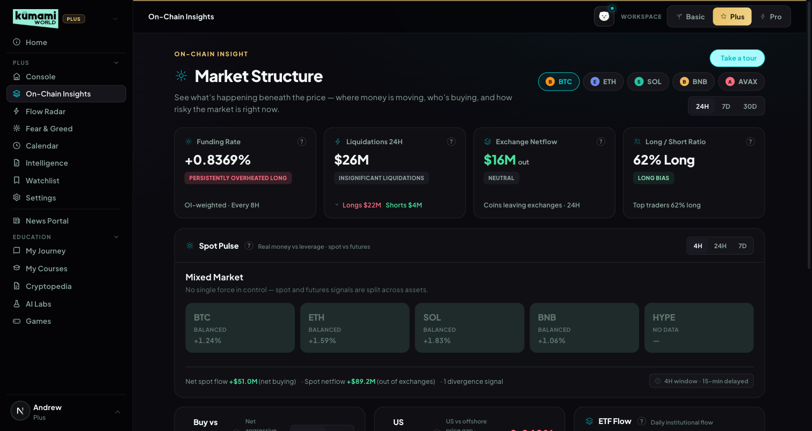
Figure: On-Chain Insights — asset/range selector, Funding Rate / Liquidations / Exchange Netflow / Long-Short tiles, and the embedded Spot Pulse panel.

How the user uses it
Pick an asset tab (BTC/ETH/SOL/BNB/AVAX) and a range (24H/7D/30D) at the top — every panel below re-fetches for that selection. Read each panel's colored verdict tag and one-line headline first; expand into the mini trend chart for detail. The banner reads “Data delayed 15 min · Upgrade to Pro for real-time.”

How we build it

Via API

2.1 Funding Rate
What it is: the recurring fee leveraged perpetual traders pay to hold a position — a direct read of crowd positioning.
API: /api/futures/funding-rate/oi-weight-history (OI-weighted, aggregated across exchanges). Cache: 300s.
How it's calculated: bands on the 3-cycle average funding rate; a “Persistently” modifier applies if the current band is extreme AND the last 3 cycles were all extreme in the same direction; a “· Rising Fast” tag fires if the 24h delta > +0.05%, or “· Unwinding” if an extreme reading is moving back toward zero.
3-cycle avg funding rate | Verdict | Color
> +0.15% | Overheated Long | red
+0.06% to +0.15% | Crowded Long | amber
0% to +0.05% | Neutral | grey
−0.05% to −0.01% | Mild Short Bias | grey
−0.10% to −0.06% | Crowded Short | amber
< −0.10% | Extreme Short | green
What the user sees: Funding {rate}% — {verdict} headline, “OI-weighted · Every 8H” cadence label, mini trend chart. Persistently one-sided funding is a classic squeeze setup — traders paying to stay positioned signals crowding, not conviction.

2.2 Exchange Netflow
What it is: whether coins are leaving exchange wallets (accumulation/bullish) or arriving (distribution/bearish).
API: /api/exchange/balance/list + /api/exchange/balance/chart. Cache: 600s.
How it's calculated: netUsd = −(balance change) × price (positive = net outflow = accumulation).
Net flow | Verdict | Color
≥ +$1B | Strong Accumulation | green
+$200M to <+$1B | Accumulation | green
>+$50M to <+$200M | Mild Accumulation | grey-green
−$50M to +$50M | Neutral | grey
<−$50M to >−$200M | Mild Distribution | grey-red
−$1B to ≤−$200M | Distribution | red
≤ −$1B | Heavy Distribution | red
Divergence tags (when flow is accelerating, |netUsd| > $50M, and price is moving): price up + net inflow → “Distribution into Strength” (red) · price down + net outflow → “Accumulation on Dip” (green) · price up + net outflow → “Conviction Rally” (green) · price down + net inflow → “Panic Selling” (red).
What the user sees: “{$X}M net {in/out}” colored bull/bear, verdict tag, “Coins leaving/arriving exchanges · {range}”, chart of total exchange balance (falling = bullish). Combines the flow direction with price context so a move can be read as conviction vs. panic, not just “up” or “down”.

2.3 Long/Short Ratio
What it is: how crowded the perpetual long/short trade is, plus whether top traders are positioned differently from the crowd.
API: /api/futures/global-long-short-account-ratio/history + /api/futures/top-long-short-account-ratio/history (Binance). Cache: 300s each.
Global % long | Verdict | Color
> 75% | Extremely Crowded Long | red
65–75% | Crowded Long | amber
55–65% | Long Bias | grey-green
45–55% | Balanced | grey
35–45% | Short Bias | grey-red
25–35% | Crowded Short | amber
< 25% | Extremely Crowded Short | green
Smart-money divergence: gap = top-trader %long − global %long. gap < −15 → “Smart Money Fading the Crowd” (amber); gap > +15 → “Smart Money Leading Long” (green); |gap| ≤ 15 → no tag.
What the user sees: “Long {X}% / Short {100−X}% — {verdict}”, a global vs. top-trader % line overlay, and the divergence tag when present. A crowded trade is fragile; when “smart money” diverges from the crowd, that's historically a more reliable signal than the crowd's own position.

2.4 Buy vs Sell Pressure (CVD)
What it is: whether a price move is backed by real aggressive buying/selling (Cumulative Volume Delta) or is hollow/liquidity-driven.
API: /api/futures/aggregated-cvd/history + /api/spot/aggregated-cvd/history. Cache: 300s each.
Price | CVD | Verdict | Color
Up | Up | Buyer-Led Rally | green
Up | Flat | Liquidity-Driven Rally | amber
Up | Down | Distribution Rally | red
Down | Down | Seller-Led Decline | red
Down | Flat | Forced Liquidation Decline | amber
Down | Up | Accumulation Decline | green
Flat | any | Neutral CVD Signal | grey
Spot-vs-futures divergence tag: futures up + spot flat/down → “Speculative Move — Spot Not Confirming” (amber); spot up + futures flat → “Organic Move — Spot Leading” (green).
What the user sees: dual chart of CVD vs. price with a shaded divergence region; a Futures/Spot toggle switches the charted CVD series. This is the single clearest “is this rally real” read on the platform.

2.5 US Demand Premium (Coinbase Premium)
What it is: the price gap between Coinbase (US demand) and the global average BTC price. Always computed on BTC regardless of the selected asset tab.
API: /api/coinbase-premium-index. Cache: 300s.
Premium | Verdict | Color
> +0.3% | Strong US Premium | green
+0.1% to +0.3% | Mild US Premium | grey-green
−0.1% to +0.1% | Neutral | grey
−0.3% to −0.1% | Offshore Leading | amber
< −0.3% | US Discount | red
Cross-signal overrides (using the shared exchange-flow direction from §2.2): Strong US Premium + exchange outflow → “Institutional Accumulation Signal” (green); US Discount + exchange inflow → “Retail Distribution Signal” (red). 7-day trend tags: sustained positive streak → “Sustained Institutional Demand”; flips positive → “US Demand Returning”; flips negative → “US Demand Fading.”
What the user sees: a premium % stat colored bull/bear, a verdict chip, a zero-lined trend chart, and Avg/Trend stats. One of the earliest tells for a genuinely new market regime.

2.6 ETF Flow
What it is: daily net creation/redemption flow through US spot BTC/ETH ETFs.
API: /api/etf/bitcoin/flow-history or /api/etf/ethereum/flow-history (chain follows the selected asset — ETH selects the Ethereum ETF, everything else defaults to Bitcoin). Cache: 900s.
Daily flow | Verdict | Color
≥ +$500M | Heavy Institutional Buying | green
+$100M to <$500M | Solid ETF Inflow | green
+$10M to <$100M | Mild Inflow | grey-green
−$10M to <+$10M | Neutral Flow | grey
−$100M to >−$10M | Mild Outflow | grey-red
−$500M to >−$100M | ETF Redemptions | red
≤ −$500M | Heavy Institutional Exit | red
A separate 7-day cumulative verdict is shown as the headline stat (Sustained Institutional Accumulation > +$1B down to Sustained Institutional Distribution ≤ −$1B). Cross-signal tags (can stack): daily ≥$500M + rising Coinbase premium → “Dual Institutional Signal”; daily ≤−$500M + exchange inflow → “Institutional Exit Confirmed”; daily inflow + 7D price decline → “Accumulating Into Weakness”; daily outflow + 7D price gain → “Selling Into Strength”.
What the user sees: headline = 7D net flow figure, verdict chip uses the daily verdict, a diverging green/red bar chart with a dashed price overlay. Slow-moving but hard to fake.

2.7 Open Interest Trend
What it is: total leveraged futures positions read against price direction.
API: /api/futures/open-interest/aggregated-history + /api/futures/price/history (Binance). Cache: 300s / 120s.
OI direction | Price direction | Verdict | Color
Up | Up | Trend Strengthening | green
Up | Flat | Leverage Building | amber
Up | Down | Overleveraged Market | red
Down | Up | Short Covering Rally | amber
Down | Flat | Deleveraging | grey
Down | Down | Capitulation / Unwind | grey
Flat | any | Stable OI | grey
What the user sees: total OI + % change over range headline, a dual OI-vs-price chart with a shaded divergence region. Rising OI with rising price is a healthy trend; rising OI with falling price precedes a long-squeeze cascade.

2.8 Stablecoin Supply
What it is: combined circulating market cap of major stablecoins — a read of “dry powder” on the sidelines. Not asset-scoped.
API: /api/index/stableCoin-marketCap-history. Cache: 1800s (the slowest-refreshing panel — treated as a macro indicator, not a trade trigger).
30D change | Verdict | Color
≥ +5% | Dry Powder Building | green
+1% to <+5% | Mild Capital Inflow | grey-green
−1% to +1% | Neutral | grey
−5% to −1% | Capital Deploying | grey
≤ −5% | Stablecoin Drain | amber
What the user sees: total stablecoin cap + “30D {change}%” headline, a simple area chart, no price overlay. “Capital Deploying” is deliberately colored neutral grey since it can be bullish or bearish either way — the code makes no assumption.

2.9 Spot Pulse (embedded panel)
What it is: “where is real money moving?” — a grid of per-asset tiles comparing spot buying/selling vs. futures leverage vs. price, plus a market-wide read and up to 3 divergence alert cards. Rendered on this On-Chain tab (not inside the Pro dashboard's own placeholder “Spot Pulse” slot — see the Pro section).
API: /api/spot/aggregated-cvd/history · /api/futures/aggregated-cvd/history · /api/futures/price/history · /api/spot/netflow-list.
Per-asset verdict (price_direction: >+1% UP · −1..+1% FLAT · <−1% DOWN; cvd_direction: beyond ±2% of the 7-day rolling std-dev of same-interval CVD deltas):
Price × Spot CVD × Futures CVD | Verdict | Color
UP × UP × UP, |spotΔ|/|futΔ| > 0.4 | REAL BUYING | bright green
UP × FLAT × UP | SPECULATIVE | amber
UP × DOWN × UP | DISTRIBUTION | red
FLAT × UP × any | ACCUMULATION | green @ 70% opacity
DOWN × UP × any | REVERSAL SETUP | green, glow border
DOWN × DOWN × DOWN | COHERENT DECLINE | muted red-grey
DOWN × FLAT × DOWN | FORCED DECLINE | amber @ 70% opacity
else | BALANCED | neutral dark
Market-wide verdict (Plus = 5 tiles): ≥3 tiles in {REAL BUYING, ACCUMULATION, REVERSAL SETUP} → “Broad Buying” · ≥2 SPECULATIVE → “Speculation Dominant” · ≥2 DISTRIBUTION → “Distribution Wave” · ≥2 ACCUMULATION with 0 DISTRIBUTION → “Selective Accumulation” · ≥2 in {COHERENT DECLINE, FORCED DECLINE} → “Broad Selloff” · else → “Mixed Market”. (Pro's thresholds scale for a 10-tile grid — see the Pro section for why they're currently unreachable.)
Divergence alert cards (top 3 by score, BTC/ETH get ×1.3): DISTRIBUTION +5 · SPECULATIVE with spot/fut ratio <0.2 +4 · ACCUMULATION within ±1% price +4 · REVERSAL SETUP +3 · REAL BUYING with spot CVD >$50M +2.
What the user sees: 5 colored tiles (asset, price, 24h%, verdict-tinted background), a market-wide verdict banner with a one-line sentence (hardcoded template today — no LLM key wired yet), up to 3 alert cards, footer stats. Arguably the single most useful “is this rally real” read on the platform.
Live status note: the verdict engine is fully live. Per-asset spot VOLUME and Pro's dynamic Row-2 (top-5-by-volume) both need /api/spot/coins-markets, which is tier-locked on the current CoinGlass key — so today BOTH Plus and Pro render the same 5 fixed anchors (BTC/ETH/SOL/BNB/HYPE); Pro's Row 2 activates automatically once the plan is upgraded, no code change needed.

3. Flow Radar
Live event feed — what just happened in the market, as it happens.

What it is
A standalone, filterable live feed of large on-chain/exchange/liquidation/smart-money events, plus a market-wide verdict band summarizing the last 4H window.
Plus tier scope: fixed 5-asset roster (BTC/ETH/SOL/BNB/HYPE), 4 event types, HIGH + MED severity only (LOW filtered server-side), real-time delivery (no delay — Plus's speed already matches Pro; Pro's upgrade is breadth, not speed).

Where it is
Tier: Plus.
Nav path: Sidebar → Plus (group) → Flow Radar.
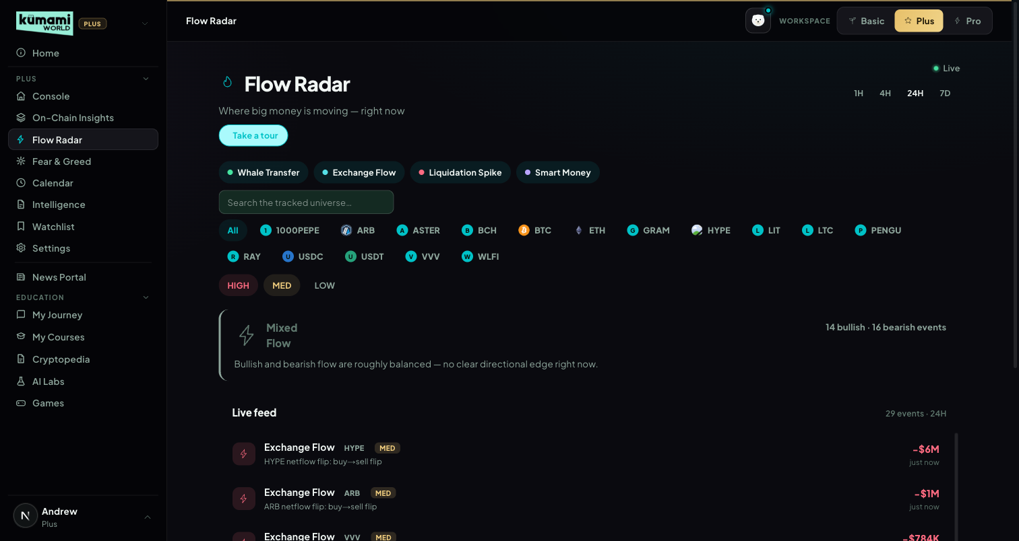
Figure: Flow Radar — event-type filter chips, asset chips, severity toggle, verdict band, live feed.

How the user uses it
Toggle the 1H/4H/24H window; tick event-type chips (Whale Transfer / Exchange Flow / Liquidation Spike / Smart Money) and asset chips to filter; use the severity toggle (HIGH/MED) to control noise; read the verdict band for the window's overall lean; scroll the live feed list, which paginates as more events load.

How we build it

Via API
Event type | API | HIGH | MED | Direction logic
Whale Transfer | /api/chain/v2/whale-transfer | > $100M | $10–100M | to exchange = Inflow (bearish) · from exchange = Outflow (bullish)
Exchange Flow | /api/exchange/chain/tx/list | > $500M | $100–500M | net direction over a 1H rolling window
Liquidation Spike | /api/futures/liquidation/coin-list | > $200M/h | $50–200M/h | always tagged “Sell Pressure” (doesn't yet distinguish long-flush vs short-squeeze direction at the event level)
Smart Money (Hyperliquid) | /api/hyperliquid/whale-alert | confidence > 0.8 | otherwise | open long = “Smart Money” (bullish) · open short/accumulation = “Accumulation”
Market Verdict Band — first match wins:
Condition | Verdict | Color
bearish $ > $500M AND ≥3 bearish events | Distribution Wave | red
bullish $ > $500M AND ≥3 bullish events | Broad Accumulation | green
total liquidation $ > $300M | Liquidation Cascade Detected | amber
≥3 bullish AND ≥3 bearish events | Mixed Flow | grey
else | Quiet Flow | grey
Bullish-leaning directions: Outflow, Buy Pressure, Support Wall, Accumulation, Smart Money. Bearish-leaning: Inflow, Sell Pressure, Resistance Wall. Each verdict ships a matching sentence and a stat line. Whales and forced liquidations move first — surfacing them live, filtered to a manageable 5-asset roster, is Plus's stickiest single feature.

4. Fear & Greed Index
A composite of five sourced, dated factors — not a bare number.

What it is
A full standalone tab (vs. just the index bar on Console) — a 5-metric weighted composite scored 0–100, with historical context.

Where it is
Tier: Plus.
Nav path: Sidebar → Plus (group) → Fear & Greed.
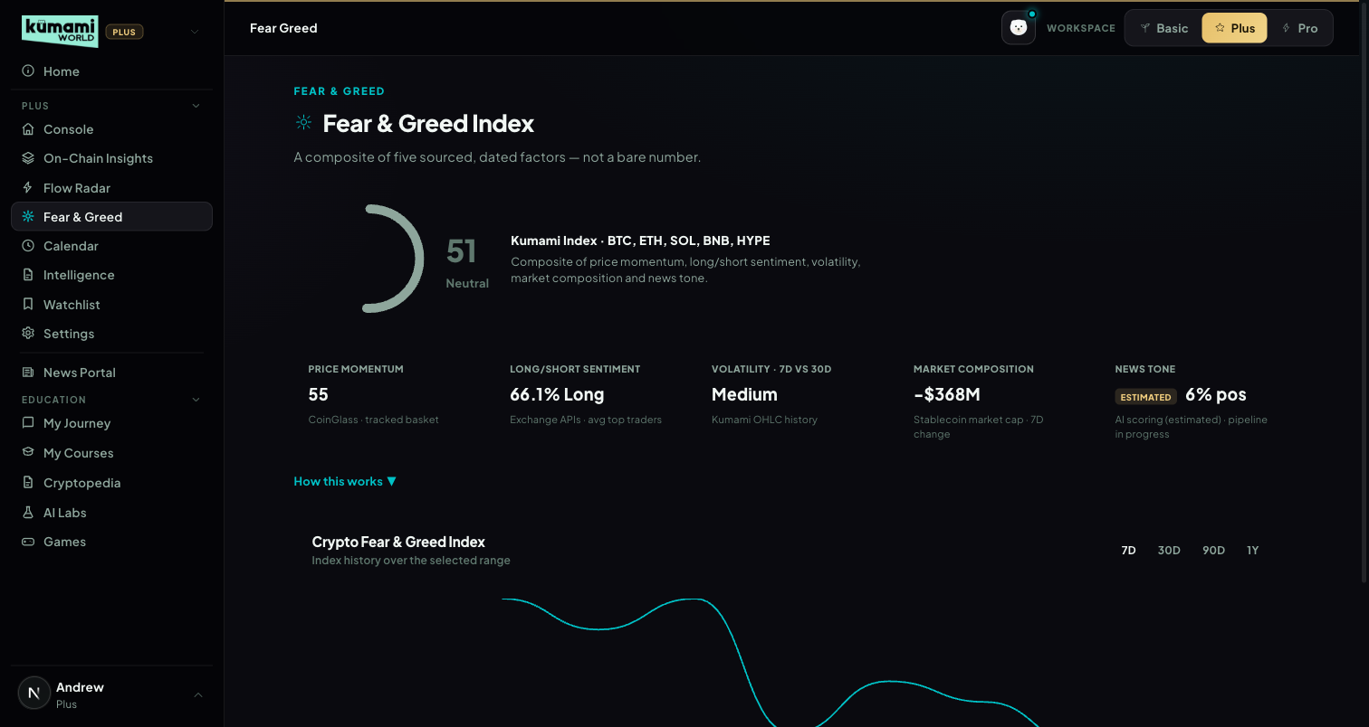
Figure: Fear & Greed Index — circular gauge, 5 sub-metric tiles, historical trend chart.

How the user uses it
Read the circular gauge (score + label) and the 5 sub-metric tiles below it; click “How this works” to expand the methodology explainer; switch the historical chart's range (7D/30D/90D/1Y) to see the trend.

How we build it

Via API
composite = Price Momentum×0.30 + Long/Short Sentiment×0.20 + Volatility×0.15 + Market Composition×0.20 + News Tone×0.15. Bands: 0–24 Extreme Fear · 25–45 Fear · 46–55 Neutral · 56–74 Greed · 75–100 Extreme Greed.
Sub-metric | Data source | Measures | Scoring
Price Momentum | Daily price history, weighted basket (BTC 50%/ETH 25%/SOL 10%/BNB 10%/HYPE 5%) | (price − 30D avg)/30D avg | >+20%→95 · >+10%→80 · −10..+10%→55 · ≥−20%→25 · else→5
Long/Short Sentiment | Long/short account ratio, same basket | % long, contrarian | >75%→95 · >65%→80 · >55%→62 · 45–55%→47 · 35–45%→32 · 25–35%→17 · <25%→5
Volatility (7D vs 30D) | OHLC history | 7D realized vol ÷ 30D realized vol | >1.5→7(High) · >1.2→22(High) · >0.9→50(Med) · >0.7→70(Low) · else→90(Low)
Market Composition | Stablecoin market-cap index | 7D stablecoin supply change, inverted | >+$5B→7 · >+$2B→25 · ±$2B→50 · ≥−$5B→75 · else→92
News Tone | Live Intelligence headlines, keyword heuristic (marked “Estimated” — no LLM classifier wired yet) | % recent headlines bullish | >75%→92 · >60%→75 · 40–60%→50 · 25–40%→27 · else→8
Known simplification: the historical chart currently plots the raw upstream Fear & Greed index history as a proxy trend line, not a full backfill of the platform's own 5-metric composite.

5. Calendar
Full economic calendar + token unlocks + protocol events.

What it is
A merged, filterable list of macro economic prints and token-unlock events (protocol/governance events reserved for a future editorial pipeline — not yet populated).

Where it is
Tier: Plus.
Nav path: Sidebar → Plus (group) → Calendar.
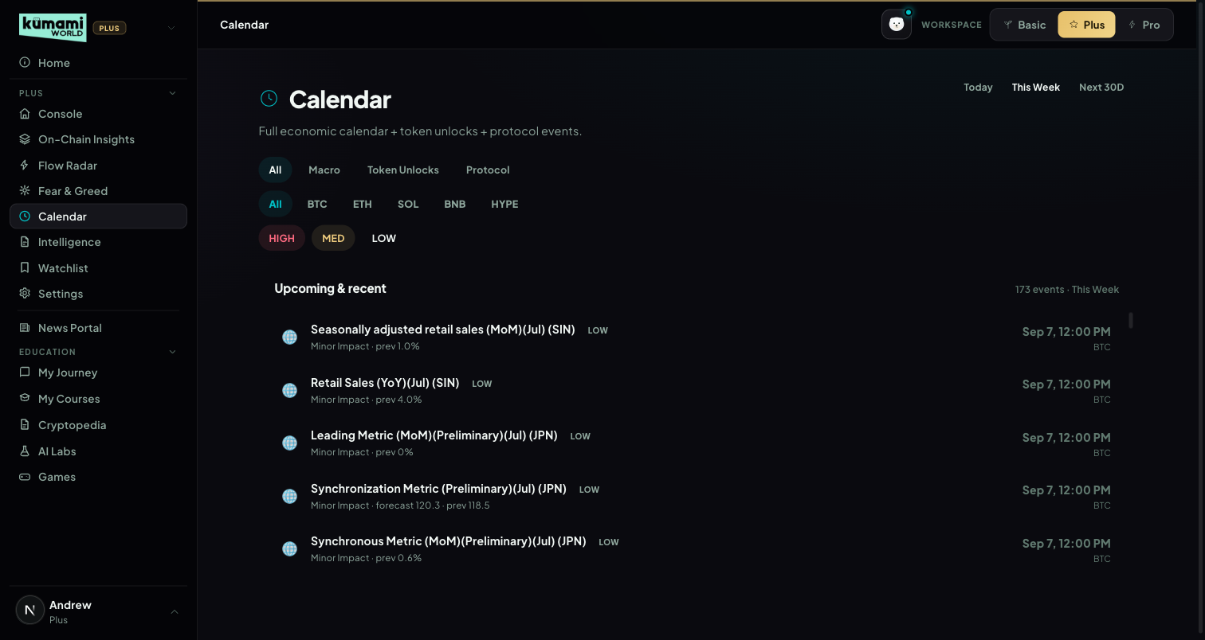
Figure: Calendar — type/impact/asset/timeframe filters above a chronological event list.

How the user uses it
Filter by type (All/Macro/Token Unlocks/Protocol), impact (HIGH/MED/LOW), asset chips, and timeframe (Today/This Week/Next 30D); scroll the chronological list below. A “D-1” popup fires once per browser when a HIGH-impact event falls within the next 24 hours.

How we build it

Via API
Macro events: /api/calendar/economic-data. Token unlocks: /api/coin/unlock-list. Cache: 1800s.
Event type | HIGH | MED | LOW
Macro (economic-data) | importance_level ≥ 3 | importance_level = 2 | importance_level ≤ 1
Token Unlock (mcap > $50M only) | unlocked % of supply > 5% | 1–5% | < 1%
Known simplification: list view only — a day/week/month calendar grid is specced as the primary view but not yet built (Pro's Calendar tab does have the month grid — see Pro §14, a separate feature/collection). “Protocol” events have no content pipeline yet (filter chip exists, always empty). The D-1 popup fires per-browser via localStorage, not app-wide on next login.

6. Watchlist
Per-asset live price, regime, and up to two action tags — personalization is the paid upsell.

What it is
A live table of a curated symbol list, each row showing price, 24h change, a regime label, and up to two severity-ranked action tags.
Asset roster: a fixed 10-symbol curated list — BTC, ETH, SOL, BNB, XRP, DOGE, AVAX, LINK, ADA, SUI (note: HYPE is NOT in this list, unlike Console/Fear-Greed/Spot Pulse/Calendar's 5-asset roster). Free/base-tier viewers see the first 5 (BTC, ETH, SOL, BNB, XRP); Plus/Pro viewers see all 10.

Where it is
Tier: Plus.
Nav path: Sidebar → Plus (group) → Watchlist.
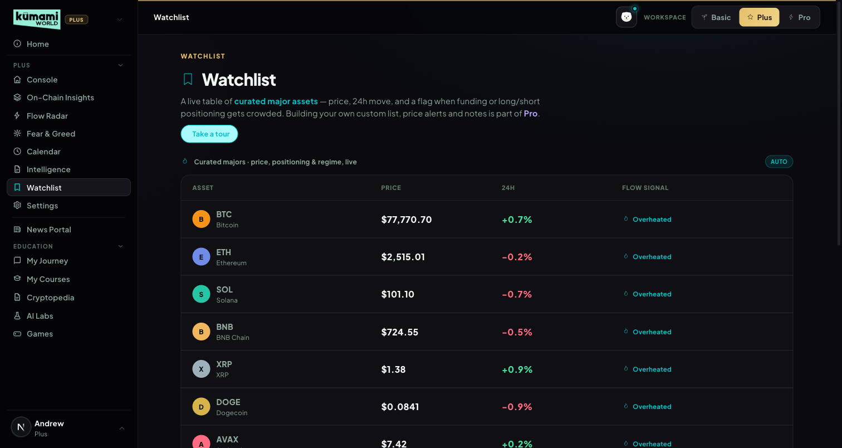
Figure: Watchlist — curated majors table with price/24h/flow-signal columns; pinning and alerts are Pro upsells.

How the user uses it
Read the curated table (Asset / Price / 24H / Flow signal) — Plus viewers see all 10 symbols read-only; the “Your pinned tokens” and “Price & whale alerts” panels below are Pro-gated, shown here as an upsell (“Open Following & Alerts” routes to the Pro tab rather than being built inline on this page).

How we build it

Via API
Per asset: Price + 24h: /api/futures/pairs-markets. Funding rate: /api/futures/funding-rate/oi-weight-history. Long/short ratio (perp assets only): /api/futures/global-long-short-account-ratio/history. Capped at 3 CoinGlass calls per asset; the whole payload is cached 300s per user.
Up to 2 action tags per asset (most severe wins):
Signal | Tag (color) | Threshold
Funding rate | Overheated (red) | > +0.10%
Funding rate | Short Heavy (amber) | < 0%
Long/short ratio | Crowded Long (amber) | > 70% long
Long/short ratio | Crowded Short (amber) | < 30% long
Tie-break: red > amber; within the same color, funding-rate tags outrank long/short tags. A separate, uncapped regime tag (Trending Up / Trending Down / Ranging) is derived from a same-direction approximation of OI vs. price (in practice “Coiling” can't occur live, since OI direction is approximated from price direction rather than fetched independently, to cap API call budget).
Known gap vs. the Console preview: the page's own copy (“auto-curated from bullish flow”) describes the separate Radar Watchlist engine used only on the Console preview panel (§1.4) — the live table here is actually the fixed curated-list + action-tag engine above. Liquidation-proximity tags (“Near Liq Zone”/“Watch Level”) are defined in the rule engine but are currently unreachable in the live builder, since that data is tier-locked pending Liquidation Heatmap integration.

7. Intelligence
A/B/C-scored briefs from news, calendar, and unlocks — the deeper read of the News Portal.

What it is
A ranked river of briefs, each tagged A (market-moving), B (worth knowing), or C (context), built from news articles, macro calendar events, and token unlocks.

Where it is
Tier: Plus.
Nav path: Sidebar → Plus (group) → Intelligence.
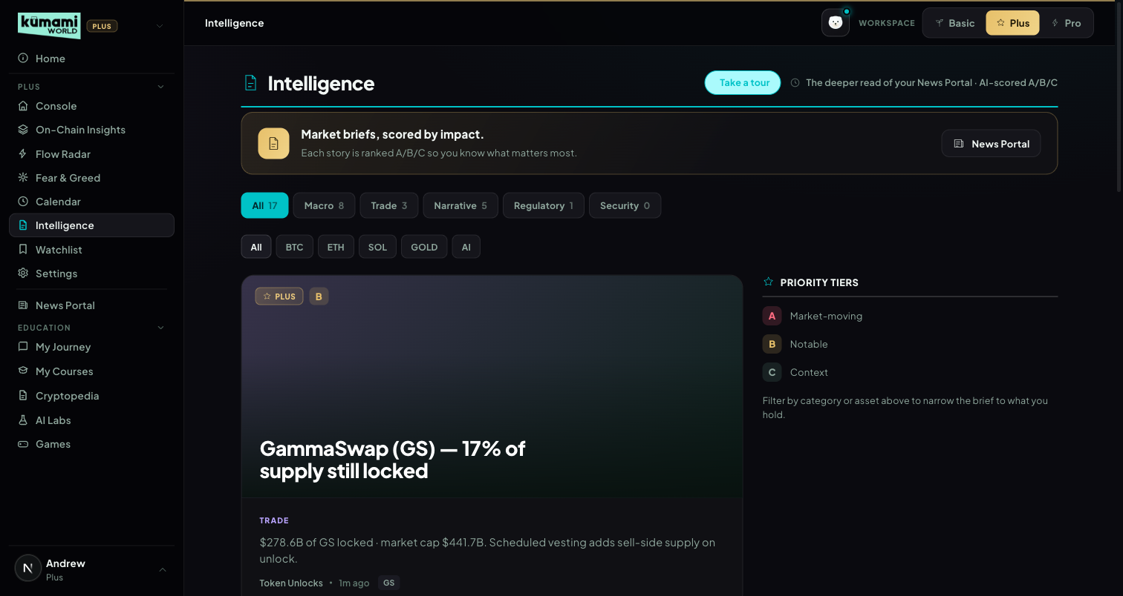
Figure: Intelligence — lead story card, Priority tiers legend, category/asset filter chips, Latest briefs river.

How the user uses it
Read the lead story card (top-ranked brief); use the category chips (All/Macro/Trade/Narrative/Regulatory/Security) and asset filter chips to narrow the river; scroll the “Latest briefs” list below; check the “Priority tiers” legend aside for what A/B/C mean.

How we build it

Via API
/api/article/list (600s) · /api/calendar/economic-data (1800s) · /api/coin/unlock-list (1800s). Route-level cache 300s, tier-independent; a “proInterpretation” AI-commentary field exists in the schema but is not yet implemented (always false/stripped) — a disclosed TODO, not a bug.
Impact keywords (first match wins, HIGH checked first): HIGH = sec, regulat, etf, hack, exploit, fed, cpi, rate cut/hike, lawsuit, ban. MEDIUM = upgrade, partnership, listing, delisting, unlock, mainnet, launch, integration. Else LOW. Timing: age < 6h → now; < 72h → scheduled; ≥72h → evergreen (news); calendar/unlock items use proximity-to-now and importance_level similarly.
Impact ↓ / Timing → | now | scheduled | evergreen
High | A (red) | B (amber) | C (grey)
Medium | B (amber) | B (amber) | C (grey)
Low | C (grey) | C (grey) | C (grey)
Category auto-detection (first match wins): Macro → fed/cpi/rate/inflation/gdp/jobs/fomc/economy; Regulatory → sec/regulat/lawsuit/ban/compliance/court; ETF Flows → etf/blackrock/ibit/inflow/outflow/fund; On-Chain → tvl/defi/staking/whale/on-chain; Trade → listing/unlock/perpetual/futures/exchange; default → Narrative. Asset auto-detection: word-boundary match against a fixed ticker list, capped to 4 assets per brief. Source names matching “coinglass” are always rewritten to “Market Wire” — the data aggregator is never surfaced to the end user.
Known gaps: the “Security” category chip and the “GOLD”/“AI” asset filter chips have no corresponding live-data path today — they will always show empty against live data.

8. Settings
Standard account management.

What it is
Profile, plan, notification preferences, language — a placeholder page today. Explicitly scoped as “not detailed in this brief — treat as placeholder pending separate spec,” so the current bare page is intentional, not a gap.

Where it is
Tier: Plus.
Nav path: Sidebar → Plus (group) → Settings.
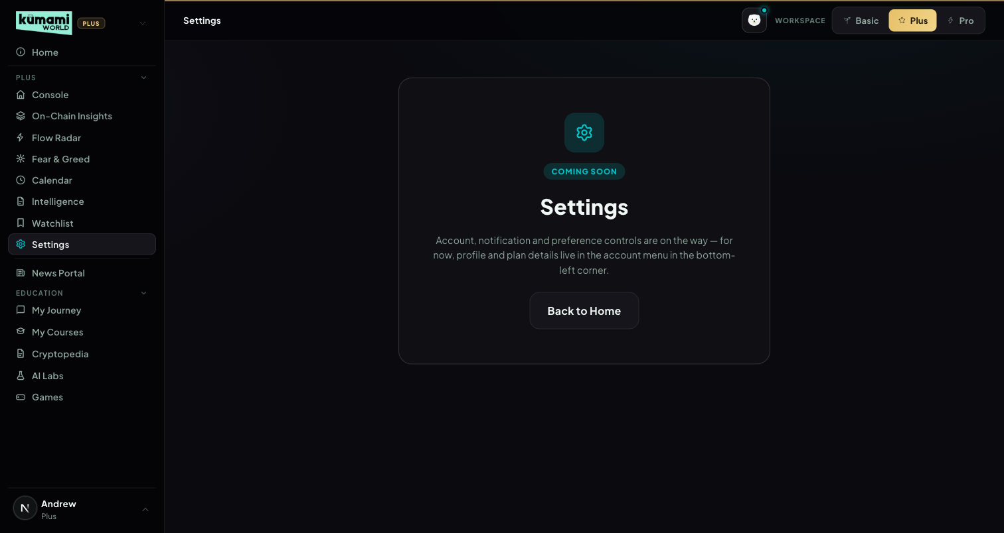
Figure: Settings — Coming Soon placeholder; profile/plan details currently live in the account menu instead.

How the user uses it
Nothing to configure yet — the page reads “Account, notification and preference controls are on the way; for now, profile and plan details live in the account menu in the bottom-left corner.” Click “Back to Home” to leave.

How we build it

Via Code only
A static placeholder component — no Firestore, no API, no admin panel.

Kumami Pro
Kumami Pro sits at /world/pro and is organized into 17 tabs, split internally into three groups: 7 fully live, Firestore/API-driven tabs; 5 pure UI placeholders sharing one generic “Coming Soon” component (Smart Money Tracker, Token Tracker, Spot Pulse, Security Scanner, Fear & Greed); and 5 re-slotted, pre-existing components migrated from the original CRA Pro Dashboard (Portfolio, Alpha Room, Market Analysis, Kuma AI, Market Cap). Non-premium users never reach any of this — they see a locked teaser instead. Any spec language implying the 5 placeholder tabs are “live” would be inaccurate; they are called out individually below.

1. Daily Digest
Rolls up every other Pro tool onto one scannable feed.

What it is
Aggregates the latest Kumami Research (pro_research), Real-Time News (pro_news), Airdrops (pro_airdrops), upcoming Calendar events (pro_calendar, filtered to today-forward, top 3), and the latest Alpha Room messages (top 3, system/image messages filtered out). Pure aggregation/sort/slice — no calculation logic. Each section links out to its full tab.
Disclosed gap: the component itself carries a static disclaimer: “Smart-money flow and a Fear & Greed read will join this digest once the market-data integration is live” — i.e. it documents that two upstream feeds are intentionally not yet wired.

Where it is
Tier: Pro only. Non-premium users never reach any of this — they see a locked teaser instead.
Nav path: Sidebar → Pro (workspace) → Pro → Daily Digest. Daily Digest is also the landing tab you reach first when you switch to the Pro workspace.
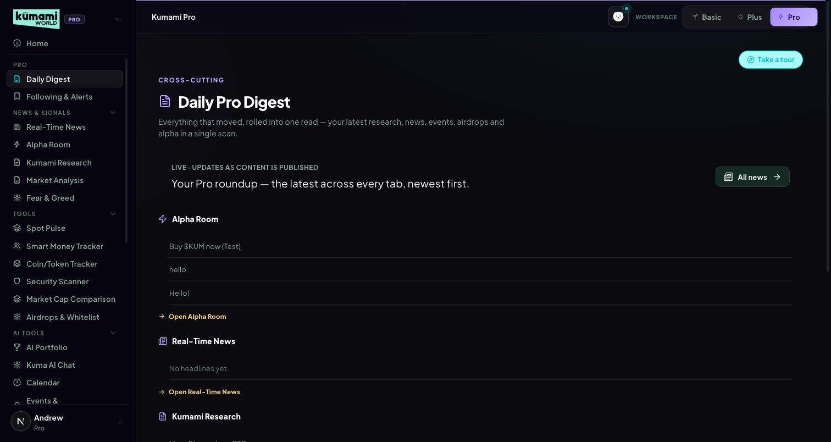
Figure: Daily Pro Digest — rolled-up feed of Alpha Room, Real-Time News, Kumami Research, Airdrops, and Calendar, each linking to its own tab.

How the user uses it
Scroll the single feed for a rollup of everything new; click any section's link (“Open Alpha Room”, “Open Real-Time News”, etc.) to jump into that tab directly.

How we build it

Via Admin Dashboard (manual)
Every source it aggregates is itself admin-authored — see Kumami Research (§13), Real-Time News (§10), Airdrops & Whitelist (§7), Calendar (§14), and Alpha Room (§11) below for each one's own admin panel. Daily Digest has no admin panel of its own; it purely reads and re-sorts those five collections.

Via API
None.

2. Following & Alerts
Per-user follow list + genuinely live price alerts.

What it is
A follow list + custom alerts persisted at users/{uid}/pro/state (Firestore). Price alerts are real: a public Binance WebSocket miniTicker stream covers 30 supported majors (BTC, ETH, SOL, BNB, XRP, DOGE, ADA, AVAX, LINK, MATIC, DOT, ARB, OP, LTC, TRX, NEAR, APT, SUI, TON, INJ, ATOM, UNI, AAVE, FIL, ETC, HBAR, ICP, RNDR, IMX, SEI).
Known gap: volume/sentiment-based triggers exist in the UI but are explicitly labeled “live monitoring soon” — not implemented yet.

Where it is
Tier: Pro only. Non-premium users never reach any of this — they see a locked teaser instead.
Nav path: Sidebar → Pro (workspace) → Pro → Following & Alerts. Also linked from the Watchlist tab in Plus (“Open Following & Alerts”).
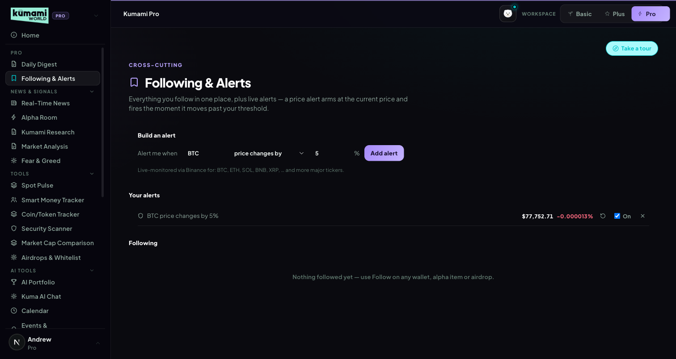
Figure: Following & Alerts — per-user follow list and price-alert configuration.

How the user uses it
Add assets to your follow list; set a price-move threshold per asset to arm an alert — it flips to TRIGGERED when the live price moves ≥ your threshold from the price it was armed at; click re-arm to reset the baseline.

How we build it

Via API
A public Binance WebSocket miniTicker stream (no key required) drives live prices for all 30 supported symbols. An alert “arms” at the first live price seen and flips to TRIGGERED when |Δ%| ≥ the user's threshold.

Via Admin Dashboard
None — the follow list and alert thresholds are entirely user-configured, written straight to the user's own Firestore document (users/{uid}/pro/state).

3. Smart Money Tracker
Wallet-level flow across market makers, funds, and on-chain whales.

What it is
Status: PLACEHOLDER — renders the generic “Coming Soon” card. No data source wired.

Where it is
Tier: Pro only. Non-premium users never reach any of this — they see a locked teaser instead.
Nav path: Sidebar → Pro (workspace) → Tools → Smart Money Tracker.
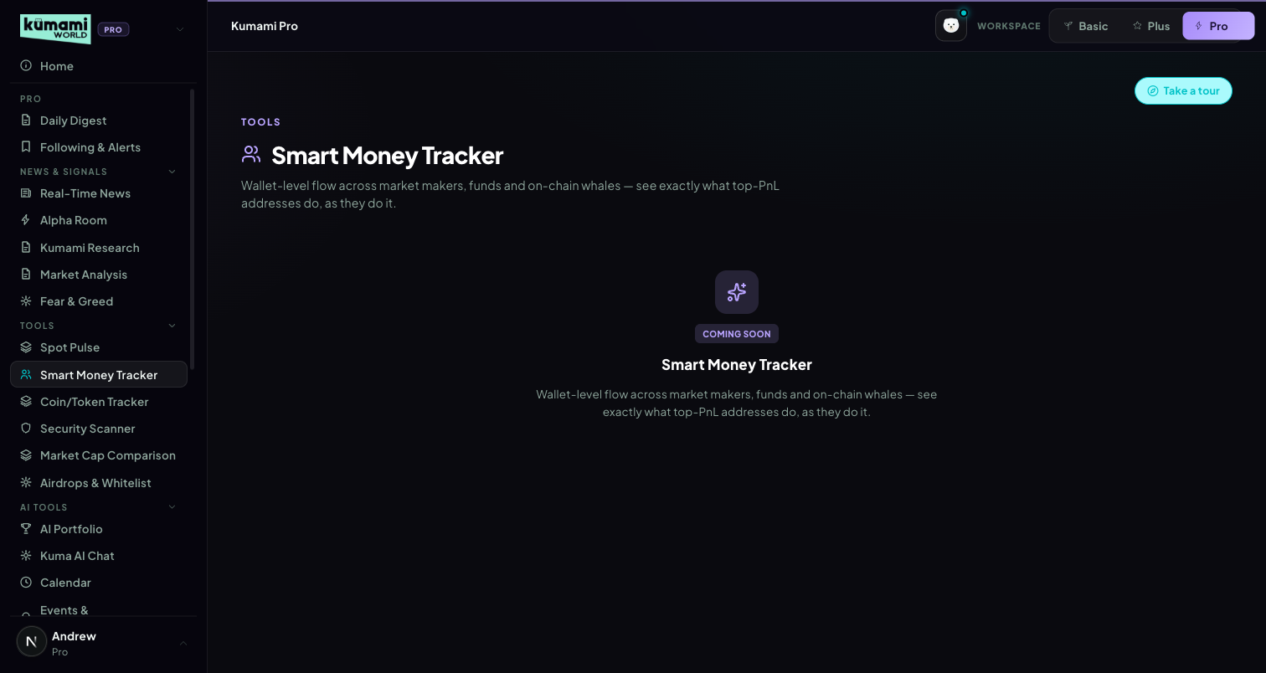
Figure: Smart Money Tracker — generic Coming Soon placeholder card.

How the user uses it
Nothing to interact with yet — the card is read-only, describing what the feature will do once built.

How we build it

Not built yet
No Firestore, no API, no admin panel — a shared “Coming Soon” UI component with feature-specific copy only.

4. Coin / Token Tracker
Deep per-token analytics with custom alerts.

What it is
Status: PLACEHOLDER — renders the generic “Coming Soon” card. No data source wired.

Where it is
Tier: Pro only. Non-premium users never reach any of this — they see a locked teaser instead.
Nav path: Sidebar → Pro (workspace) → Tools → Coin/Token Tracker.
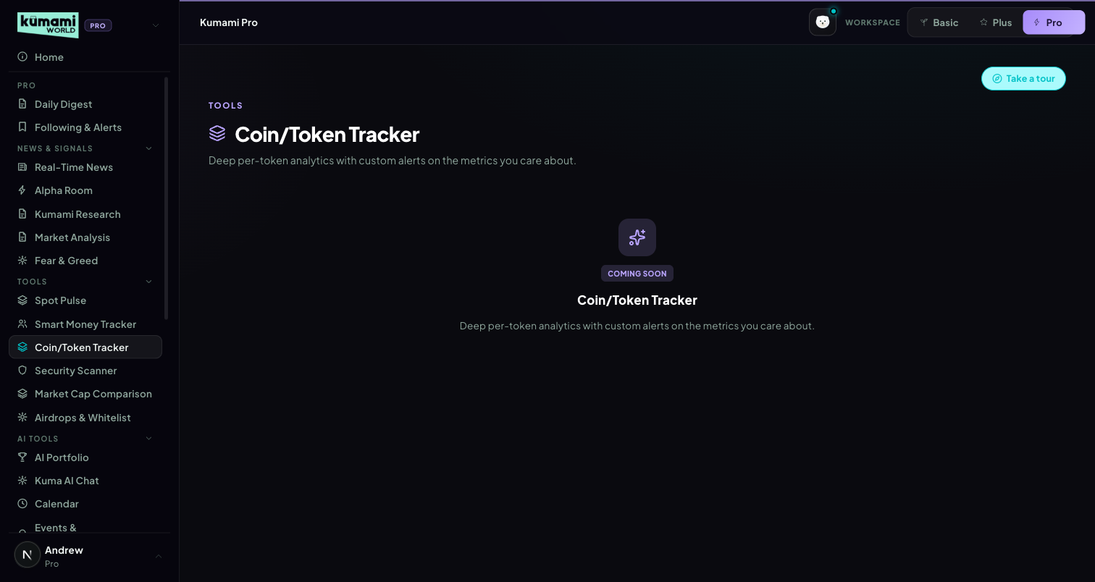
Figure: Coin/Token Tracker — generic Coming Soon placeholder card.

How the user uses it
Nothing to interact with yet.

How we build it

Not built yet
No Firestore, no API, no admin panel.

5. Spot Pulse
Spot-vs-futures activity, per token — with custom alerts.

What it is
Status: PLACEHOLDER inside the Pro dashboard's own tab — but the underlying engine is fully built and already live elsewhere (see Plus §2.9 On-Chain Insights). computeMarketVerdict() genuinely branches on tier ('plus' | 'pro') with different tile-count thresholds (e.g. Plus: buying ≥ 3 → “Broad Buying”; Pro: buying ≥ 6, assuming a 10-tile grid). The live builder, however, only ever produces the 5 fixed anchor tiles (BTC/ETH/SOL/BNB/HYPE) for both tiers today — Pro's 10-tile threshold branch is currently unreachable dead code.
Why it's blocked: the 5-anchor + 5-dynamic-trending-by-volume Row 2 needs /api/spot/coins-markets, which is tier-locked on the current CoinGlass plan. Once upgraded, Pro's Row 2 and its distinct thresholds activate automatically — no code change required.

Where it is
Tier: Pro only. Non-premium users never reach any of this — they see a locked teaser instead.
Nav path: Sidebar → Pro (workspace) → Tools → Spot Pulse. Where it actually renders today is /world/onchain (Plus's On-Chain Insights tab, §2.9) — this Pro slot is a placeholder pointing at a feature that already exists one tier down.
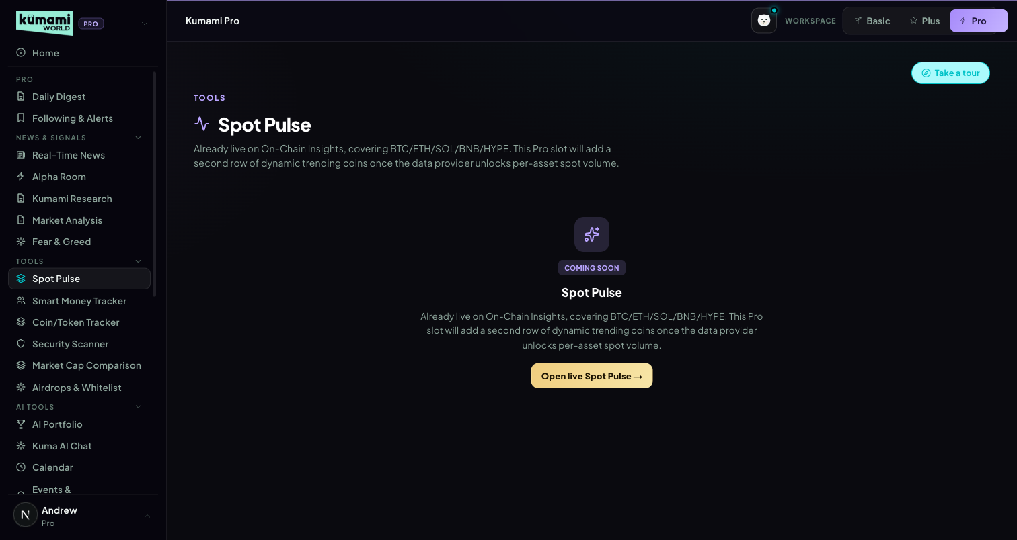
Figure: Spot Pulse (Pro slot) — generic Coming Soon placeholder; the real engine lives on Plus's On-Chain Insights tab.

How the user uses it
Nothing to interact with on this specific tab yet — for the live version, use Plus's On-Chain Insights tab instead (§2.9).

How we build it

Via API (where it actually lives)
Served via /api/market/spot-pulse, which does differentiate by tier on refresh cadence: Pro caches 15s, Plus/free caches 60s. So the speed tiering is real even though the tile-count tiering is not yet reachable.

6. Security Scanner
Contract- and wallet-level risk scoring before you interact.

What it is
Status: PLACEHOLDER — renders the generic “Coming Soon” card. Copy references honeypots, mint authority, and LP locks; no data source wired.

Where it is
Tier: Pro only. Non-premium users never reach any of this — they see a locked teaser instead.
Nav path: Sidebar → Pro (workspace) → Tools → Security Scanner.
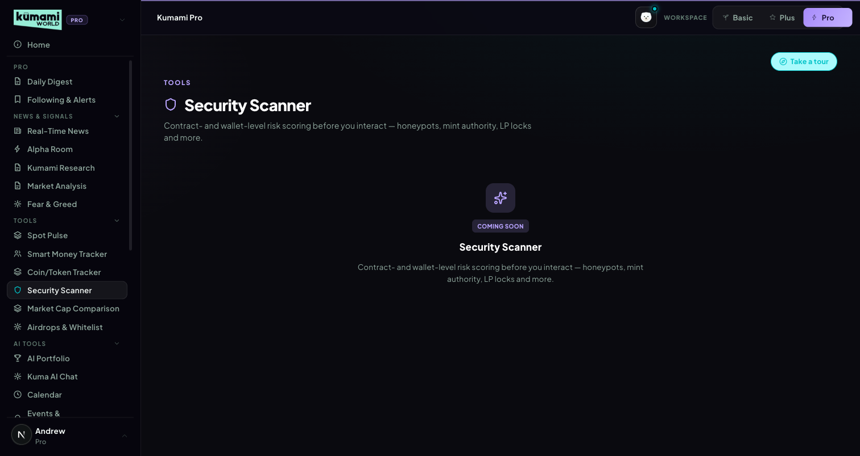
Figure: Security Scanner — generic Coming Soon placeholder card.

How the user uses it
Nothing to interact with yet.

How we build it

Not built yet
No Firestore, no API, no admin panel.

7. Airdrops & Whitelist
Admin-curated airdrop and whitelist opportunities with an eligibility checklist.

What it is
Status: LIVE (Firestore, real-time). Reads pro_airdrops (status == 'published'). Two sub-tabs (Airdrops / Whitelists), card grid → detail view with an eligibility checklist, deadline, estimated value, and a Follow toggle. No scoring — purely admin-entered content, sorted by createdAt desc client-side.

Where it is
Tier: Pro only. Non-premium users never reach any of this — they see a locked teaser instead.
Nav path: Sidebar → Pro (workspace) → Tools → Airdrops & Whitelist.
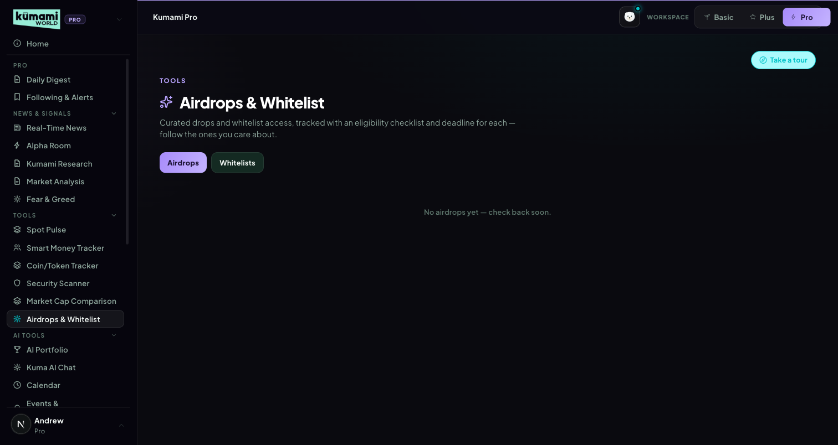
Figure: Airdrops & Whitelist — Airdrops/Whitelists sub-tabs over a card grid.

How the user uses it
Switch between the Airdrops and Whitelists sub-tabs; click any card to open its detail view — deadline, estimated value, and an eligibility checklist; click Follow to track one.

How we build it

Via Admin Dashboard (manual)
Firestore pro_airdrops, authored at Content → Pro Dashboard → Airdrops & Whitelist (/admin/pro-airdrops): Name, Category (airdrop dropdown), Description, Deadline (free text, e.g. “2d 4h” or “Not live”), Estimated value, Eligibility (checklist type), Accent color, and an “+ Add checklist item” builder → Publish or Save Draft.
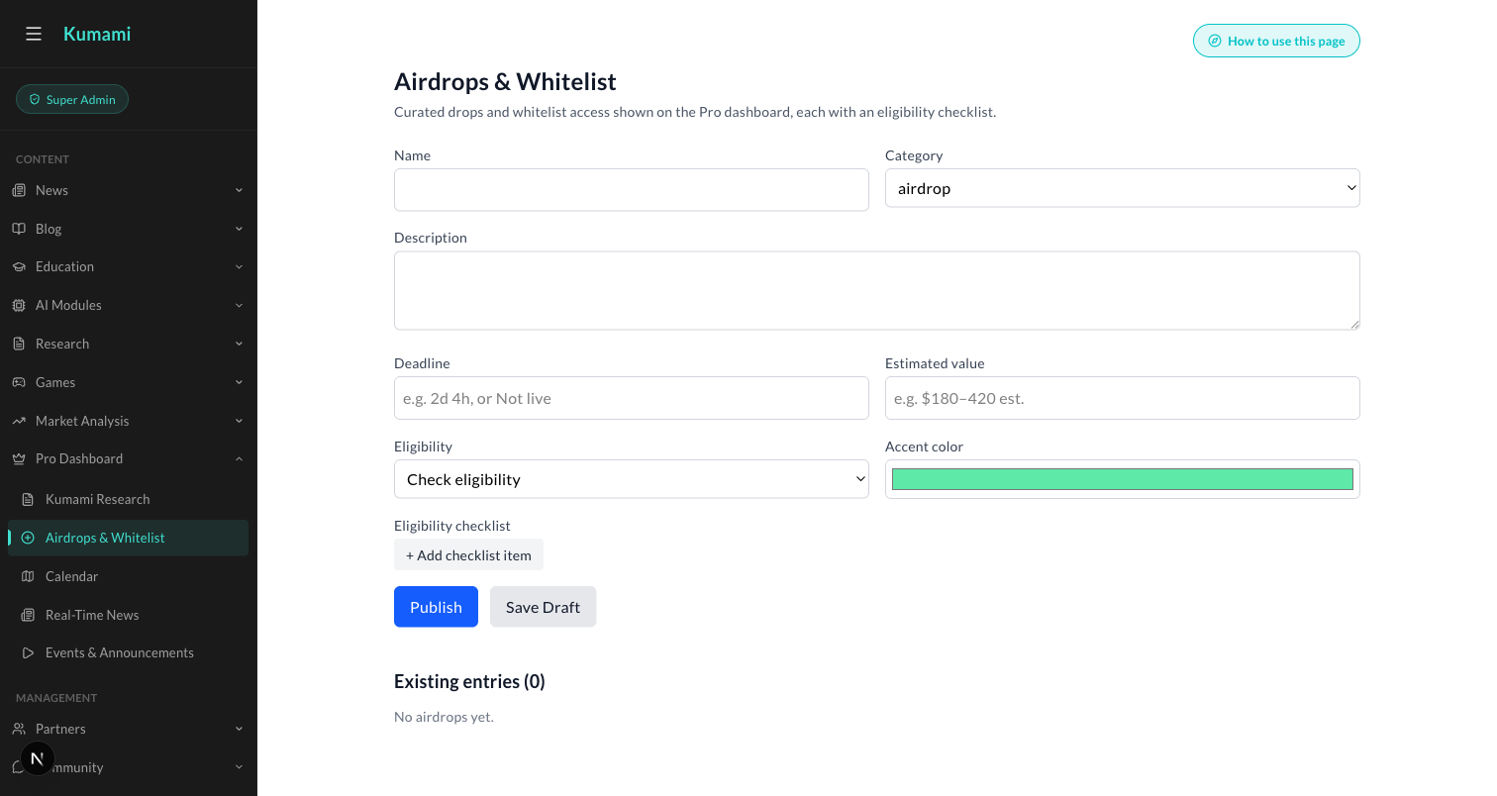
Figure: Content → Pro Dashboard → Airdrops & Whitelist — the admin form behind every Airdrops/Whitelist card.

8. AI Portfolio
Live holdings and pricing, plus an externally-scored risk scan.

What it is
Status: LIVE for holdings/pricing, with one known fabricated stat. Holdings read from users/{uid}.cryptoPortfolio (Firestore), priced live via /api/coingecko/markets (with 429 retry/backoff, plus a follow-up fetch for portfolio coins missing from the top-100 list). Add/Edit/Delete write straight back to Firestore.
Known bug — flag before shipping this as a spec'd feature: the hero card's “24h change” is NOT computed from real data — it is a hardcoded synthetic ratio, always exactly +2.3% of total balance, always shown as an increase. This actively misrepresents portfolio performance and should be fixed rather than spec'd around.

Where it is
Tier: Pro only. Non-premium users never reach any of this — they see a locked teaser instead.
Nav path: Sidebar → Pro (workspace) → AI Tools → AI Portfolio.
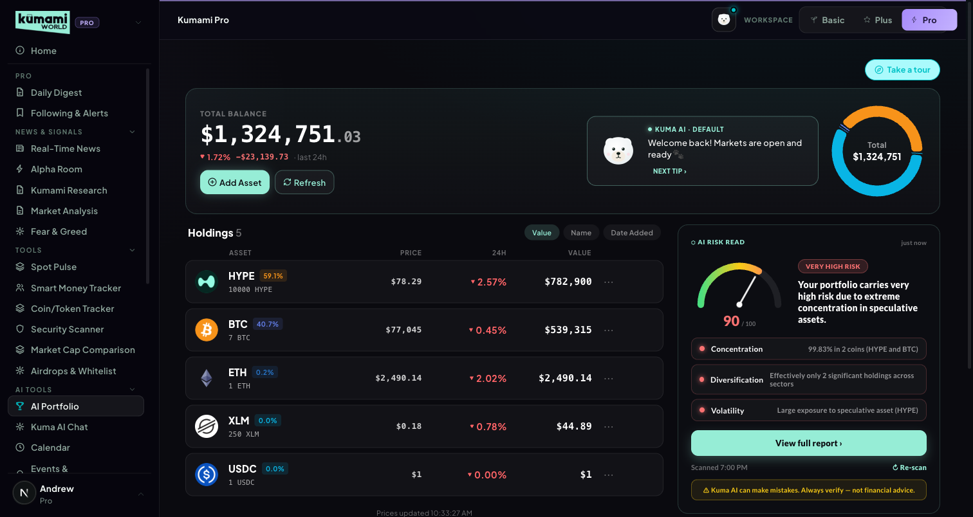
Figure: AI Portfolio — total balance, holdings table, AI risk-read panel.

How the user uses it
Click “Add Asset” to log a coin, amount, and price paid; click Refresh to re-pull live prices; click a holding's “…” menu to edit or delete it. Click “Scan my portfolio” (or “Re-scan”) to get a risk read — the result caches until your holdings change.

How we build it

Via API
Pricing: /api/coingecko/markets (429 retry/backoff). Risk scan: POST /api/portfolio-scan forwards {userId, totalValue, holdings[]} to an external n8n webhook (N8N_PORTFOLIO_SCAN_WEBHOOK_URL) and only validates/clamps the response shape (overall.score clamped 0–100, level clamped low/medium/high, dimensions limited to concentration/diversification/volatility/liquidity, actions capped at 4). The actual scoring logic — thresholds, weighting — lives outside this repo, in the n8n workflow; this codebase has no visibility into it. Results cache with a portfolio-hash staleness check (“Portfolio changed since this scan”).

Via Admin Dashboard
None — holdings are entirely user-entered, written straight to the user's own Firestore document.

9. Market Cap Comparison
“What if Coin A had Coin B's market cap?” — with real formulas.

What it is
Status: LIVE. Two searchable coin-selector dropdowns, a swap button, a stats comparison table (price/market cap/circulating supply/24h/rank/ATH/FDV), and an auto-generated insight sentence.

Where it is
Tier: Pro only. Non-premium users never reach any of this — they see a locked teaser instead.
Nav path: Sidebar → Pro (workspace) → Tools → Market Cap Comparison.
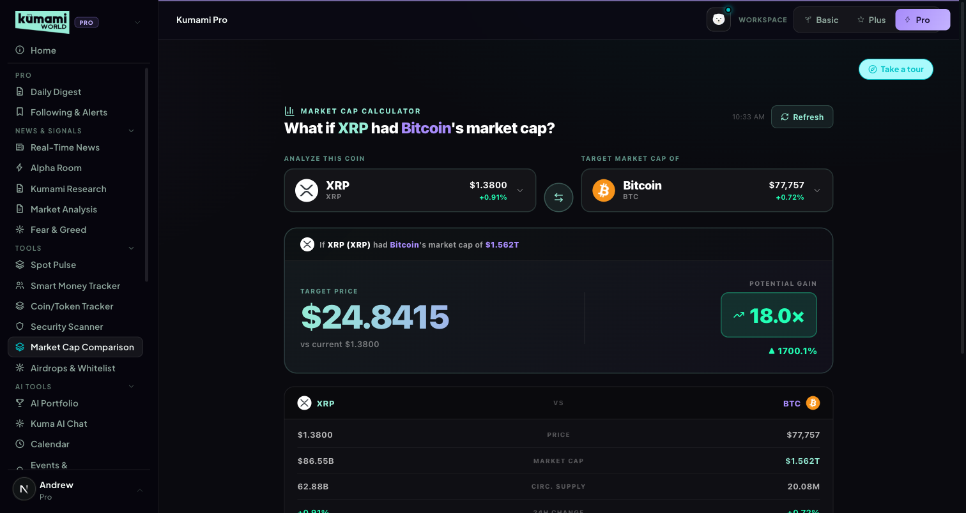
Figure: Market Cap Comparison — Coin A vs. Coin B selectors, swap button, stats table.

How the user uses it
Pick Coin A and Coin B from the two searchable dropdowns (defaults to XRP vs. BTC); click the swap button to flip them; read the comparison table and the auto-generated insight sentence below it.

How we build it

Via API
/api/coingecko/markets (top 100 coins, 429 retry/backoff).
How it's calculated: targetPrice = coinB.market_cap / coinA.circulating_supply · multiplier = targetPrice / coinA.current_price · pctChange = (targetPrice − current)/current × 100.

10. Real-Time News
Admin-curated, sentiment-tagged breaking news.

What it is
Status: LIVE (Firestore, real-time). Reads pro_news (status == 'published'). Each row: exact + relative time, headline with a sentiment dot (bull=green/bear=red/neutral=grey), one-line summary, tags, sentiment badge, source badge. Sorted newest-first.

Where it is
Tier: Pro only. Non-premium users never reach any of this — they see a locked teaser instead.
Nav path: Sidebar → Pro (workspace) → News & Signals → Real-Time News.
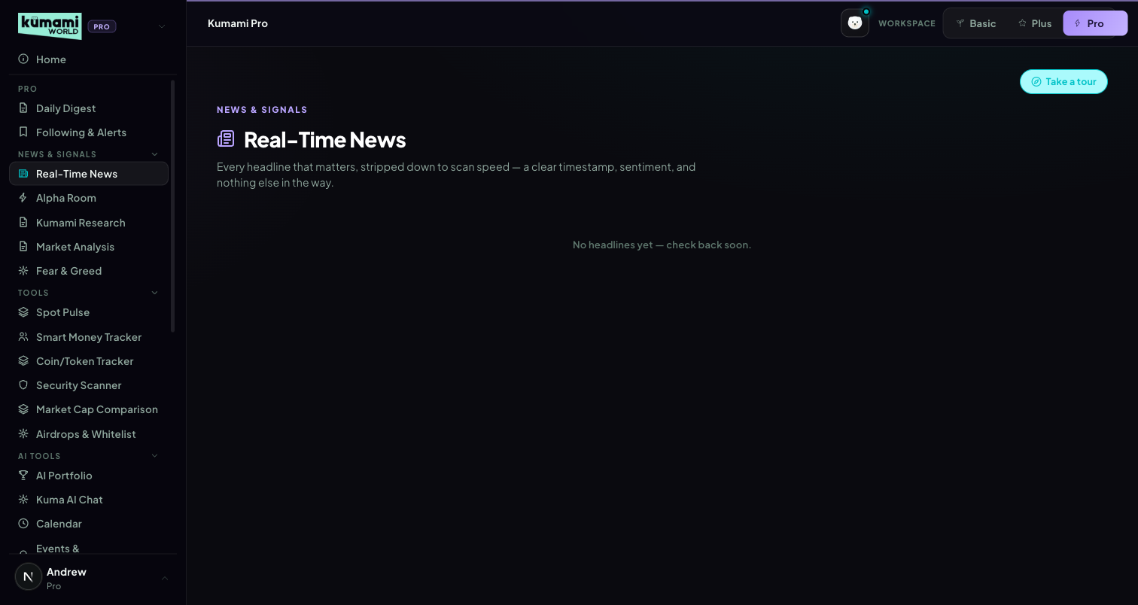
Figure: Real-Time News — sentiment-tagged headline list, newest first.

How the user uses it
Scroll the list; each row's sentiment dot (green/red/grey) gives an at-a-glance read before you even read the headline.

How we build it

Via Admin Dashboard (manual)
Firestore pro_news, authored at Content → Pro Dashboard → Real-Time News (/admin/pro-news): Headline, Sentiment (Bullish/Bearish/Neutral dropdown), Source (optional), one-line summary (optional), comma-separated Tags (optional) → Publish or Save Draft.
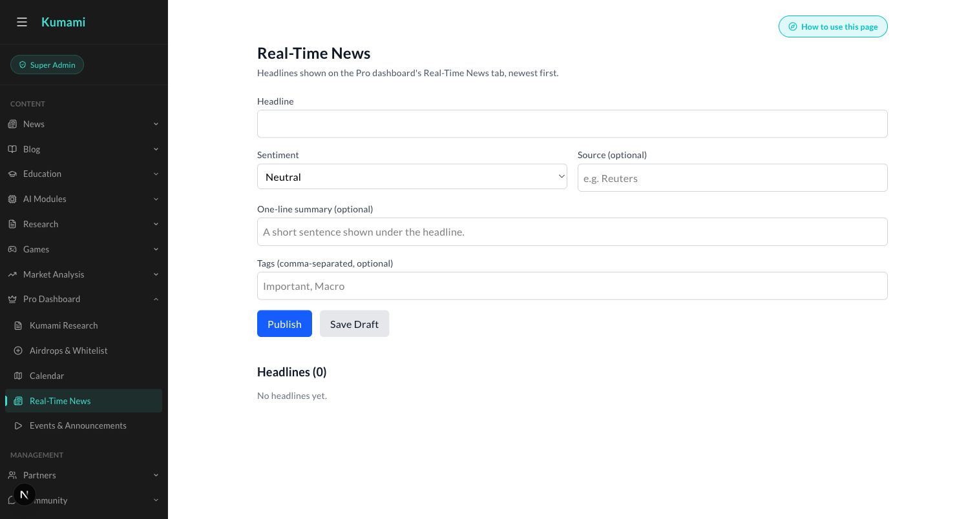
Figure: Content → Pro Dashboard → Real-Time News — the admin form behind every headline.

11. Alpha Room
A chat-style feed of curated alpha calls.

What it is
Status: LIVE (Firestore, real-time, read-only in this component). Reads the alphaRoom collection as a chat-style feed — system messages (centered pill) and user/image messages (chat bubble, avatar, timestamp).

Where it is
Tier: Pro only. Non-premium users never reach any of this — they see a locked teaser instead.
Nav path: Sidebar → Pro (workspace) → News & Signals → Alpha Room.
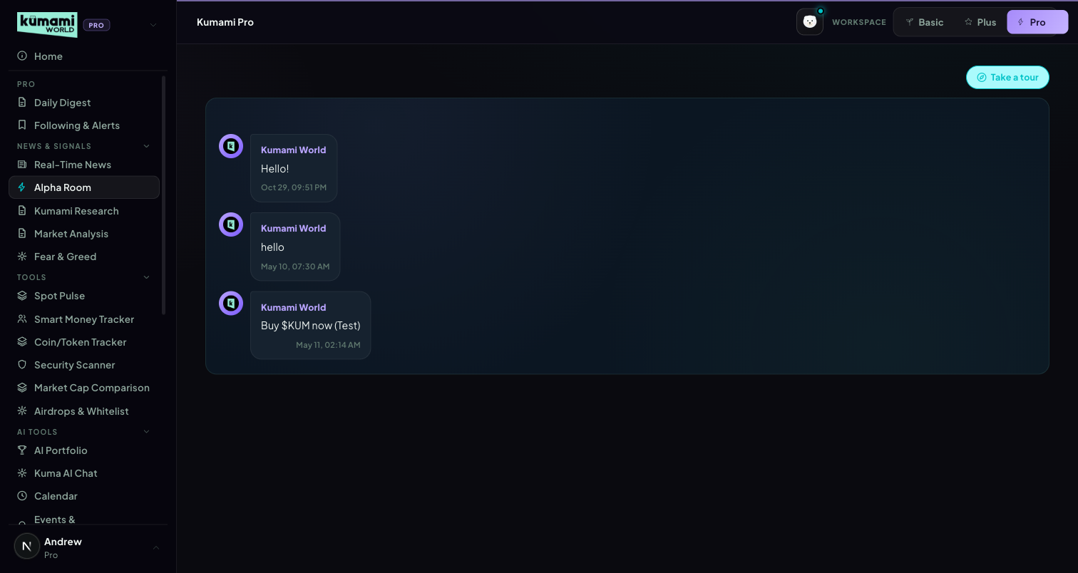
Figure: Alpha Room — chat-style feed of curated alpha calls, read-only for Pro users.

How the user uses it
Read-only feed — scroll to see the latest posted calls. There is no way to post or reply from this tab.

How we build it

Via Admin Dashboard (manual)
Firestore alphaRoom collection, authored at Management → Community → Alpha Room (/admin/alpha-room) — a chat-style composer where an admin types a message (or pastes/uploads an image) and sends it directly into the live feed as “Kumami World”. This resolves what the raw spec data left ambiguous (“presumably authored elsewhere”) — the admin panel is confirmed to be the actual write path, not a guess.
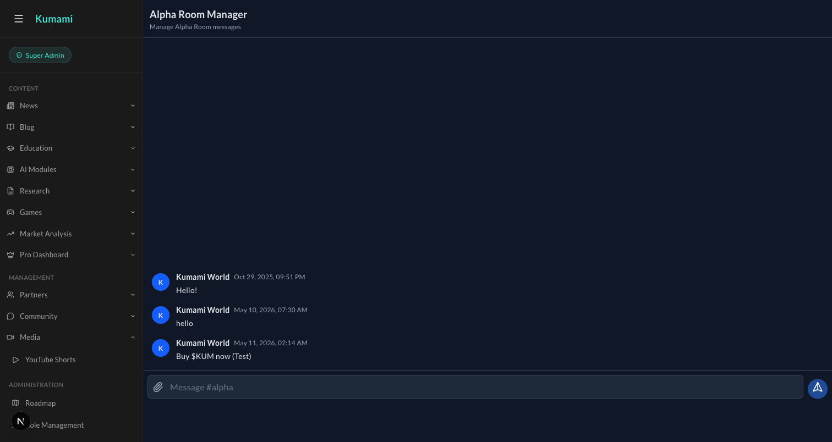
Figure: Management → Community → Alpha Room — the admin chat composer that writes directly into the live Alpha Room feed.

12. Fear & Greed
Planned multi-factor sentiment composite for Pro.

What it is
Status: PLACEHOLDER — renders the generic “Coming Soon” card, copy references a planned composite feed. No tier-specific behavior exists since nothing is implemented yet; Plus already has a fully live, more detailed Fear & Greed tab (see Plus §4) that this Pro slot has not yet absorbed or differentiated from.

Where it is
Tier: Pro only. Non-premium users never reach any of this — they see a locked teaser instead.
Nav path: Sidebar → Pro (workspace) → News & Signals → Fear & Greed. Already live elsewhere — see Plus §4 (Sidebar → Plus (group) → Fear & Greed) for the fully built version.
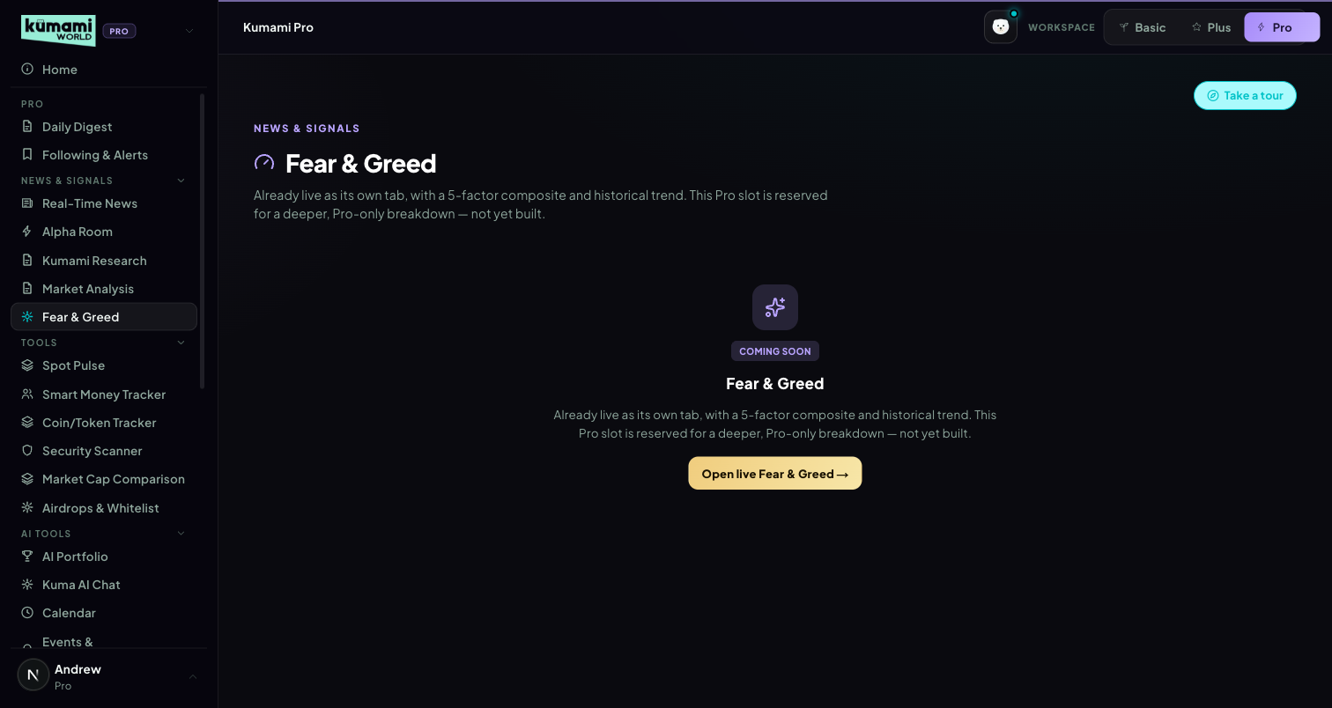
Figure: Fear & Greed (Pro slot) — generic Coming Soon placeholder; the live version is on Plus.

How the user uses it
Nothing to interact with on this specific tab — for the live version, use Plus's Fear & Greed tab instead (§4).

How we build it

Not built yet (for this Pro slot)
No Firestore, no API, no admin panel for this slot specifically.

13. Kumami Research
Admin-authored research notes with a position call.

What it is
Status: LIVE (Firestore, real-time). Reads pro_research (status == 'published'). Each card: author name/role, relative timestamp, a position badge (long/short/neutral + asset), body text, and an optional “What this means for you” premium callout. No scoring — purely authored content.

Where it is
Tier: Pro only. Non-premium users never reach any of this — they see a locked teaser instead.
Nav path: Sidebar → Pro (workspace) → News & Signals → Kumami Research.
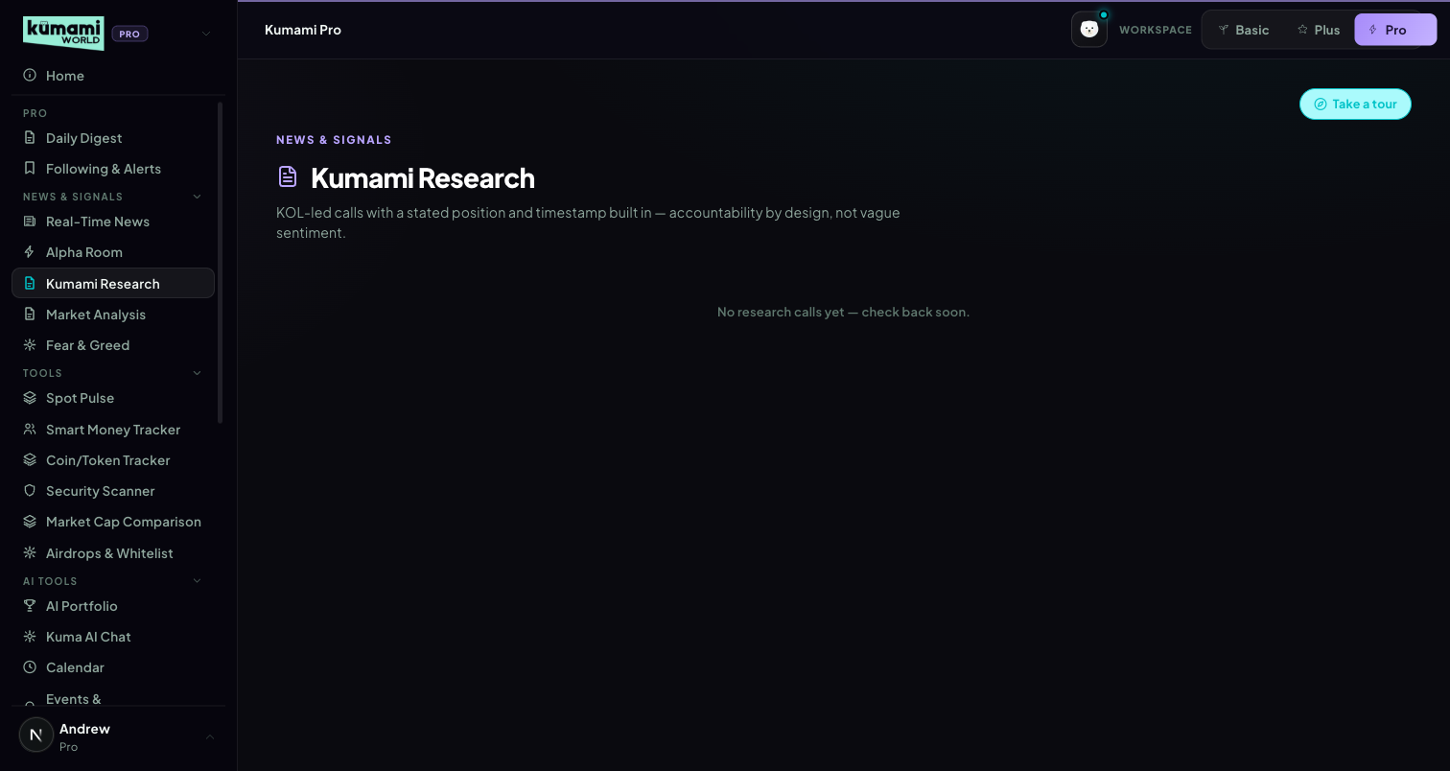
Figure: Kumami Research — author cards with a position badge and body text.

How the user uses it
Scroll the card feed; each card states its author, a long/short/neutral position badge on a specific asset, the reasoning, and (when present) a “What this means for you” callout.

How we build it

Via Admin Dashboard (manual)
Firestore pro_research, authored at Content → Pro Dashboard → Kumami Research (/admin/pro-research): Analyst name, Role/title, Position (long/short/neutral dropdown), Asset/ticker, “The call” body text, and an optional “What this means for you” field → Publish or Save Draft.
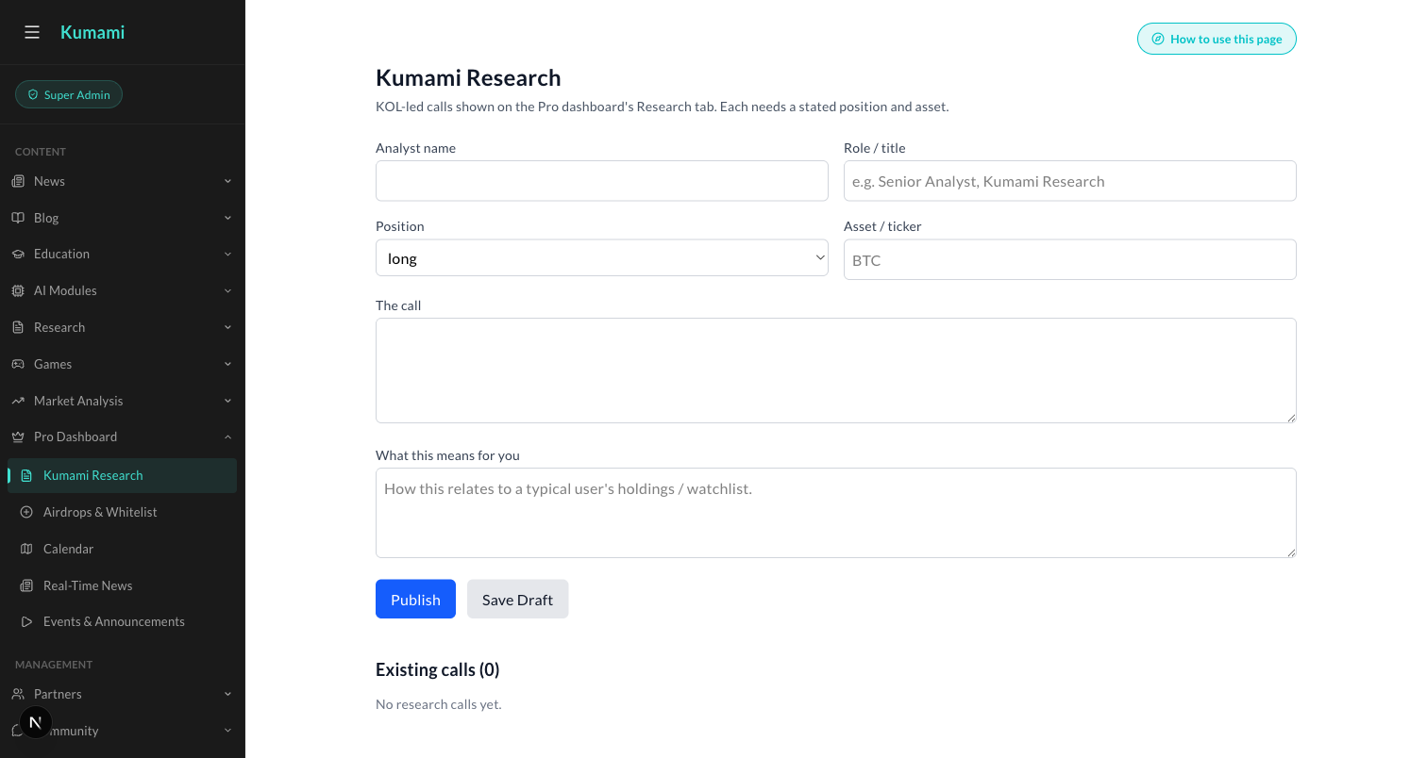
Figure: Content → Pro Dashboard → Kumami Research — the admin form behind every research card.

14. Calendar
A full month-grid calendar of admin-authored events.

What it is
Status: LIVE (Firestore, real-time). Reads pro_calendar (status == 'published'), admin-authored. A real computed month grid (first-day-of-week offset, days-in-month, padding cells), day chips colored by impact (high/med/low), a selected-event detail panel, and an “Upcoming” list (today-forward).
Note: no Plus/Pro tier distinction — same component/collection regardless of tier; this is a fully separate feature/collection from the standalone Plus Calendar tab (which reads live macro/unlock data, not admin-authored events).

Where it is
Tier: Pro only. Non-premium users never reach any of this — they see a locked teaser instead.
Nav path: Sidebar → Pro (workspace) → Calendar. (Ungrouped — sits below the AI Tools group in the sidebar.)
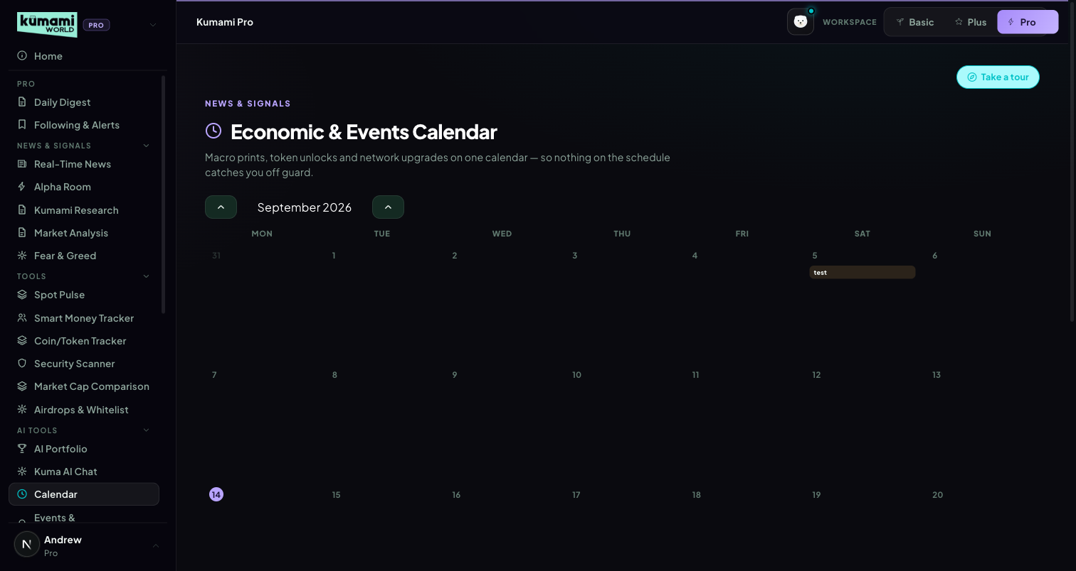
Figure: Pro Calendar — full month grid, impact-colored day chips, Upcoming list.

How the user uses it
Navigate months with the ‹ › arrows; click any day with an event chip to open its detail panel; scroll the “Upcoming” list for a flat, today-forward view.

How we build it

Via Admin Dashboard (manual)
Firestore pro_calendar, authored at Content → Pro Dashboard → Calendar (/admin/pro-calendar): Title, Date, Time (optional), Impact (High/Medium/Low dropdown), Category (Macro dropdown), Description → Publish or Save Draft. Existing entries list below with Edit/Delete.
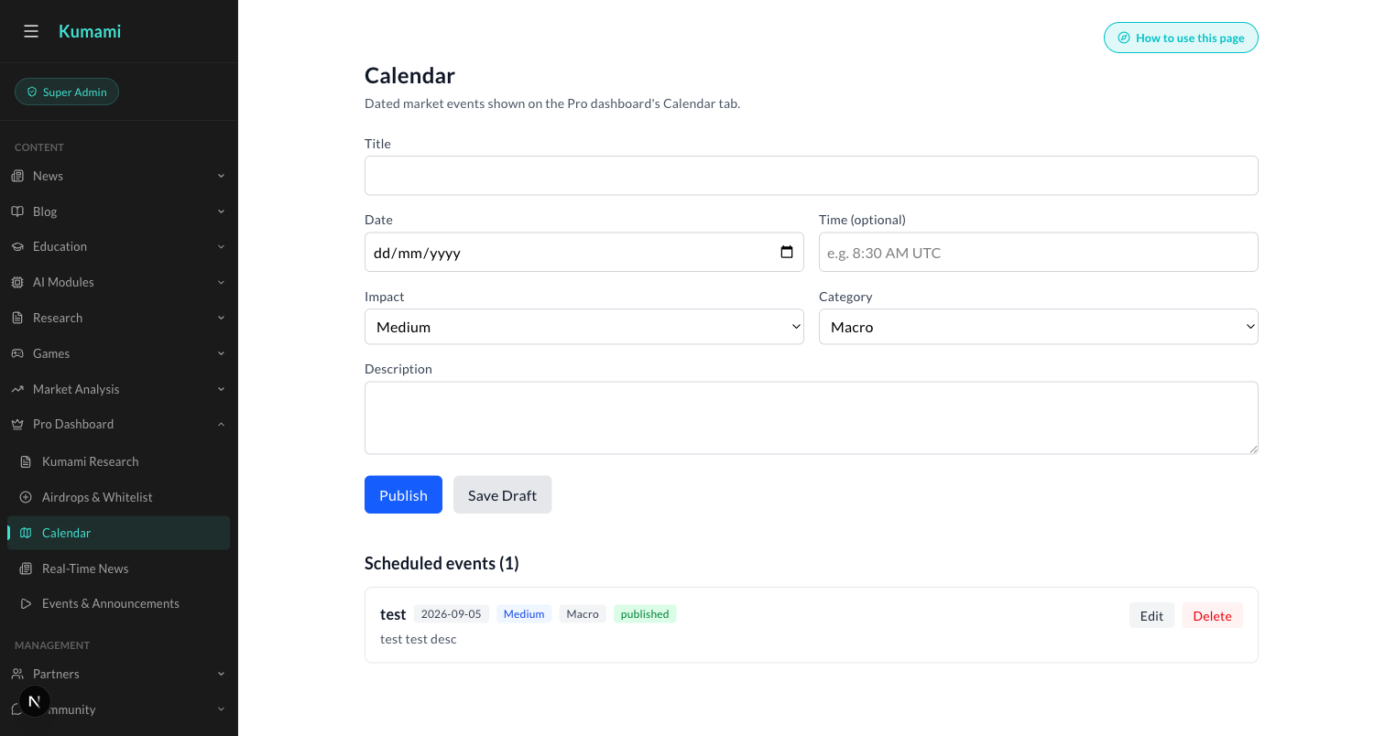
Figure: Content → Pro Dashboard → Calendar — the admin form behind every calendar event.

15. Events & Announcements
Live-streamed events with real-time audience Q&A.

What it is
Status: LIVE (Firestore, real-time, including a genuinely live sub-feature). Reads pro_events (pubStatus == 'published'), admin-authored, split into upcoming/past. Live events get a red “Live now” badge + embedded YouTube iframe.
How Q&A works: questions write to pro_events/{id}/questions, sorted by votes desc, with one-vote-per-user upvoting, a profanity/link/length moderation filter, and a client-side rate limiter before writes. Past events show a “Watch replay” toggle for the same embed. One of the more fully-built live features on the Pro surface — real-time, moderated, rate-limited audience interaction, not just static content.

Where it is
Tier: Pro only. Non-premium users never reach any of this — they see a locked teaser instead.
Nav path: Sidebar → Pro (workspace) → Events & Announcements. (Ungrouped — sits below the AI Tools group in the sidebar.)
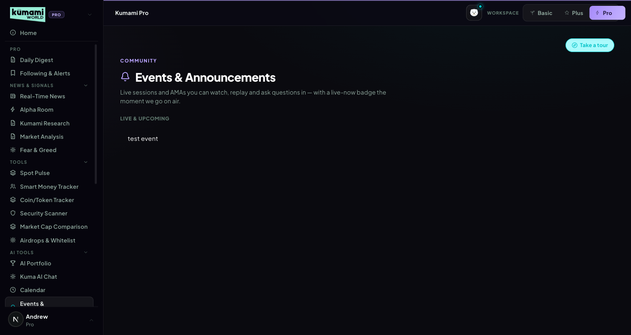
Figure: Events & Announcements — Live & Upcoming list; live events show a Live-now badge and embedded video with Q&A.

How the user uses it
Click a live event to watch the embedded stream and submit/upvote questions in the Q&A panel; click a past event to watch the replay via the same embed.

How we build it

Via Admin Dashboard (manual)
Firestore pro_events, authored at Content → Pro Dashboard → Events & Announcements (/admin/pro-events): Title, Date/time label, Host, Status (upcoming/live/past dropdown), YouTube video (id or URL), and a “Live now” checkbox (shows the Live badge + enables audience Q&A) → Publish or Save Draft.
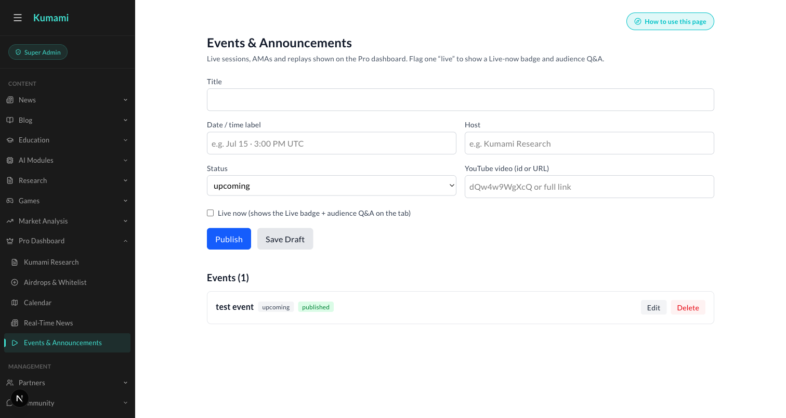
Figure: Content → Pro Dashboard → Events & Announcements — the admin form behind every event, including the Live-now toggle.

16. Market Analysis
A curated carousel of admin-authored market takes.

What it is
Status: LIVE (Firestore, real-time). Reads marketAnalysis (top 5 by createdAt desc), a hero/carousel layout with prev/next navigation, asset badge, delta badge, tag pill (Bullish/Bearish/Rotation/On-chain), author chip. Optional fields degrade gracefully if absent. No computed analysis — purely authored content with presentational formatting.

Where it is
Tier: Pro only. Non-premium users never reach any of this — they see a locked teaser instead.
Nav path: Sidebar → Pro (workspace) → News & Signals → Market Analysis.
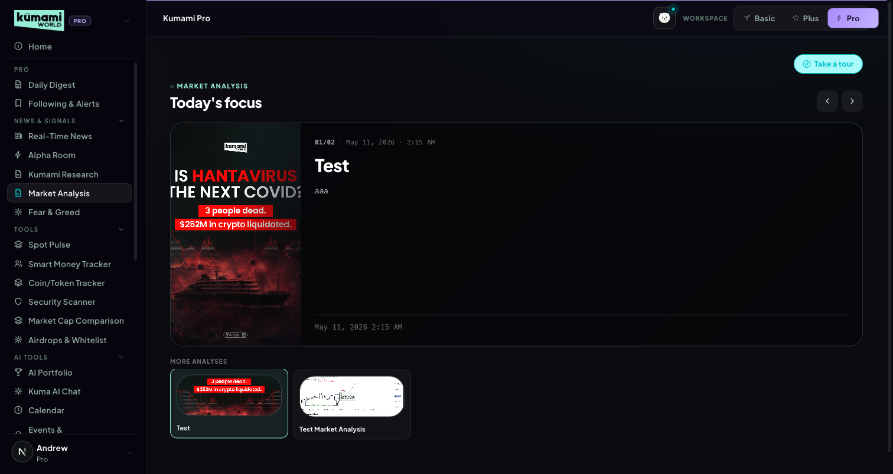
Figure: Market Analysis — hero carousel of the latest analysis, with More Analyses thumbnails below.

How the user uses it
Use the ‹ › arrows to move through the latest analyses, newest first; click a thumbnail under “More Analyses” to jump straight to it.

How we build it

Via Admin Dashboard (manual)
Firestore marketAnalysis, authored at Content → Market Analysis → Publish Market Analysis (/admin/market-analysis): Title, Content, and an Image upload → Publish Market Analysis.
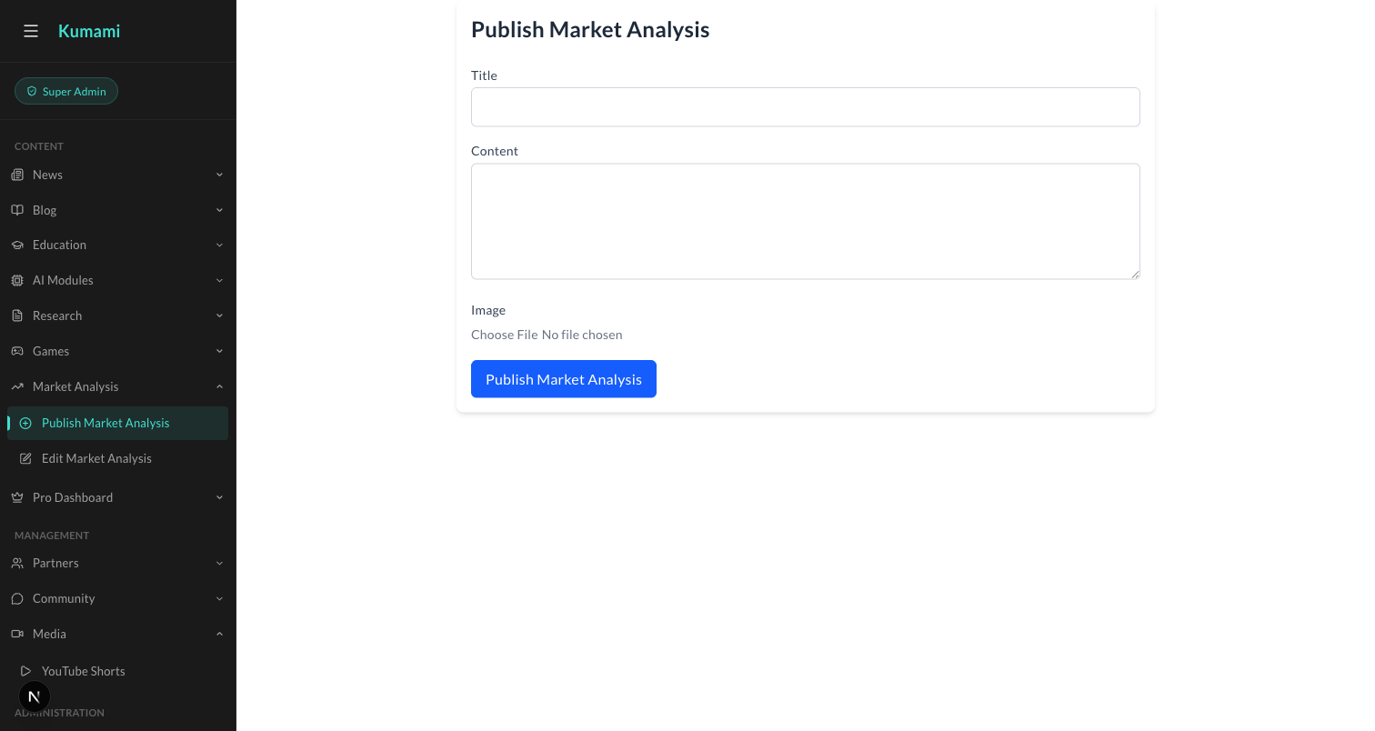
Figure: Content → Market Analysis → Publish Market Analysis — the admin form behind every carousel card.

17. Kuma AI Chat
Two products in one tab: general AI chat, and a live on-chain whale-wallet tracker.

What it is
Status: LIVE — the most substantively “real” integration in the whole Pro surface.
General chat: per-user rooms at users/{uid}/chatrooms/{roomId}/messages (Firestore real-time). Sending a message posts to an external chat API (the project's existing n8n backend). Prompt-snippet suggestions, custom markdown rendering, typing indicator, infinite-scroll pagination, room create/delete.
Crypto Address Tracker (default bot room): lets users watch up to 20 EVM wallets (ETH/Base/Arbitrum) with per-wallet USD alert thresholds and mute durations (1h/4h/24h). Wallet stats (balances, NFT counts, tx counts, top holdings) are fetched live via the Alchemy SDK server-side (Firebase ID token verified) — genuinely live on-chain data, not mocked. Alerts render direction (in/out), amount, chain, counterparty, USD value, and explorer links (Etherscan/Basescan/Arbiscan). This tab touches a real external chain-data provider (Alchemy) rather than Firestore-only content — the closest thing on the Pro surface to genuine on-chain intelligence today.

Where it is
Tier: Pro only. Non-premium users never reach any of this — they see a locked teaser instead.
Nav path: Sidebar → Pro (workspace) → AI Tools → Kuma AI Chat.
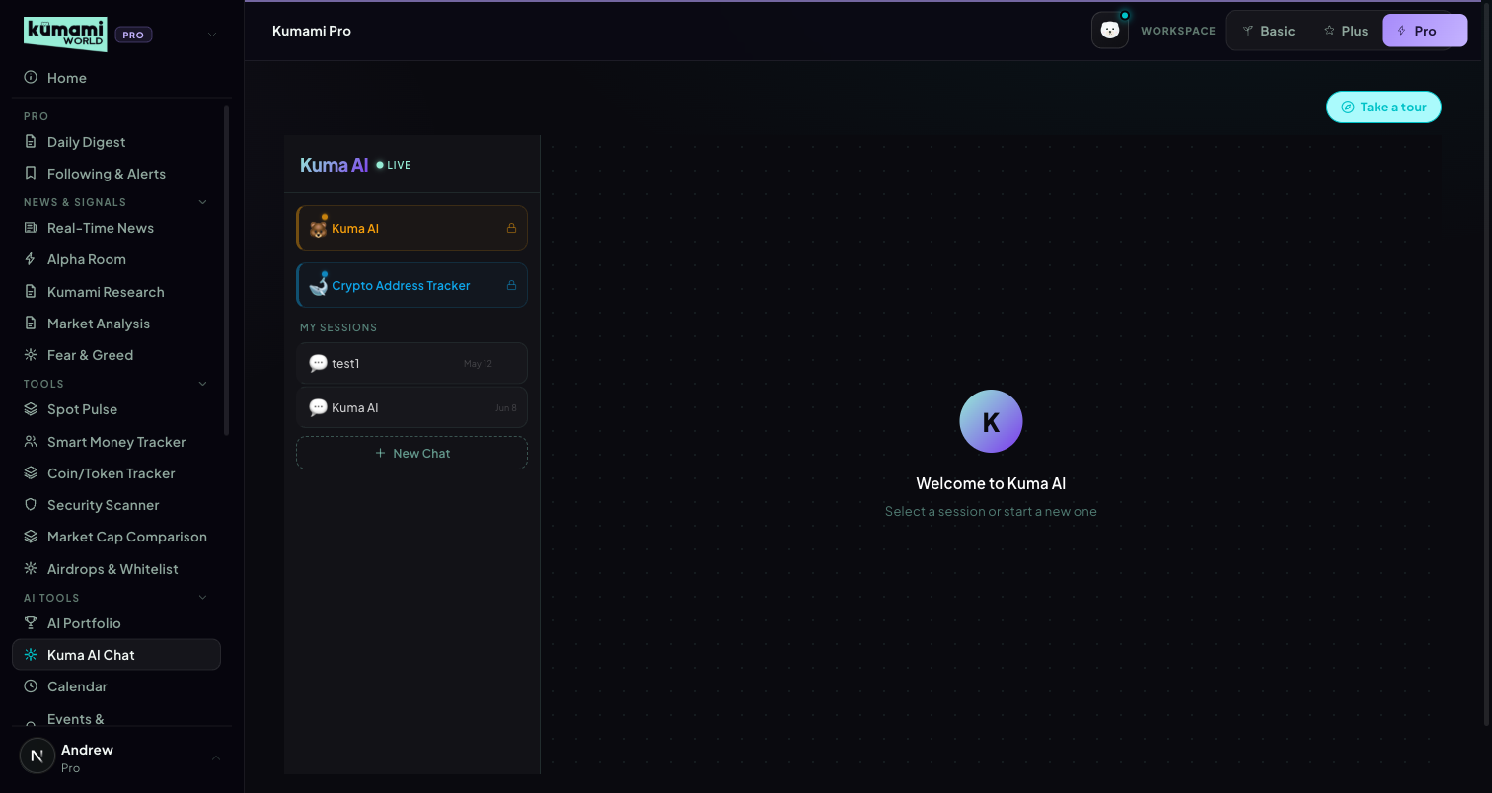
Figure: Kuma AI Chat — room list (Kuma AI, Crypto Address Tracker, My Sessions) with the main chat panel.

How the user uses it
Click “New Chat” to start a general conversation, or open the default “Crypto Address Tracker” room to add up to 20 wallet addresses with a USD alert threshold and mute duration each; past sessions are listed under “My Sessions” for quick resume.

How we build it

Via API
General chat messages post to the project's existing n8n chat backend. Wallet stats and live on-chain activity for the Address Tracker are fetched server-side via the Alchemy SDK (Firebase ID token verified) — real on-chain data, not mocked.

Via Admin Dashboard
None — rooms, messages, and tracked wallets are entirely user-configured.

